Table of Contents

Table of Contents 2
Introduction 2
Key 4
Keywords 4
Existing Keywords 5
Keyword Research 5
Keyword Cannibalisation 7
Keyword Traffic Potential 8
On Page SEO 10
Page Titles 10
Meta Descriptions 13
OG Tags & Twitter Cards 18
H-Tag Heading Structure 20
Media, Images and Alt Text 23
Links & Siloing 29
Physical Siloing & URL Structure 29
Virtual Siloing & Linking 34
Anchor Text 38
On Page Content 40
Correlation Analysis 40
Content Length 42
Content Quality & Search Intent 43
Content Ideas 44
Short Form Evergreen Content 45
Long-form articles 45
Infographics 47
Guest Articles 48
List Posts 48
How to Guides 49
Roundups 50
Final thoughts on content creation 50
Content Promotion and Outreach Strategy 52
Link Creator Database creation 52
Social Media Promotion 53
PPC 53
Strategic Partnerships and existing authority sites 53
Manual & automated outreach 54
Summary and Conclusion 55
Areas for Improvement 55
Keywords 55
On Page SEO 56
Links 57
Content 58
Appendices 58

Introduction

A content audit is the process of evaluating existing content on your site to assess its quality and performance. It highlights what content should be deleted, redirected or improved.

We evaluate your on-page SEO to check that your pages are optimised for search engines in order to reach your target audience. While we do assess key metrics, a content audit is also more qualitative in nature. Understanding your target audience’s intent is crucial for SEO and any successful content strategy. It’s not just Google that looks at your content but your audience as well, and you have to cater to both.

We look at examples of your existing content and analyse them from an SEO perspective. We tell you what’s being done right and what can be improved.

The content audit also identifies any content gaps in terms of searched topics that you have not covered. There may also be relevant keywords that are currently ranking well that you could target - we provide you with lists of these relevant search terms and phrases to use going forward.

In these ways, the audit will help you and your team to better optimise or reuse existing content that may be performing poorly.

We also provide you with ideas and step by step guides for creating new content using frameworks that are working in SEO right now. And rather than taking a publish and pray approach, we suggest strategies for promotion and outreach to get your content seen and shared.

Key

Green - Done well / trivial room for improvement
Orange - Done poorly / room for improvements
Red - Current state is detrimental to overall SEO / completely unimplemented
Blue - Our recommendation

Keywords

In SEO, keywords range from single words to complex phrases that people use in search queries in Google or other search engines. The keywords in this section will inform many of your onpage SEO choices, which is why we deal with it first in this audit.
lKEYWORDSl

To understand why keywords are important, we must understand the 2 main metrics which Google considers when ranking pages:

- Authority
  - (This is dealt with in the Competitor Audit.)
  - It is primarily measured by the number of links that point to the page (it’s pretty simple: more backlinks = more authority).
  - The quality of the backlinks also matters. A single high quality backlink can be worth dozens of low quality backlinks.
  - Internal links also play a role in passing authority around the site.
- Relevancy
  - (This is dealt with in the Content Audit.)
  - It is measured by the types of pages which the page links to (e.g. a page titled “Cars” which links to IMDB and Rotten Tomatoes is probably talking about the movie, not the physical object).
  - It is also measured by other factors (such as keywords, titles, header structure, image alt text, and so on).

The goal is to make sure your pages have relevant keywords that people are searching for so that your site can better match the searcher intent. When effectively researched and optimised, keywords will help your page organically rank higher in search results and funnel your target audience to your website.

This section will assess the keywords you are currently targeting, consider the keywords you could be targeting, and investigate whether any of your pages are cannibalising each other and lowering search volume. Finally we assess the potential increase in traffic that you can expect from ranking better for certain keywords.


Existing Keywords
Our goal is to determine whether the current keyword targeting strategy is working. And, to find untapped keywords that could result in “easy” wins.

We need to examine your current set of keywords and then examine opportunity keywords.

Are you currently targeting the right keywords?

Often, the keywords that some businesses are going after are way out of their league. They think they can win on “homerun” keywords, but they will more than likely end up failing.

We need to determine whether you should target competitive keywords or go for medium tail or long tail keywords (variations of the keywords that are less searched but still get a lot of traffic when accumulated).

DATA COLLECTION

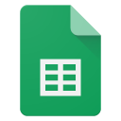 | Existing keywords
 | Top folders
 | Keyword intersect [your competitors have these keywords but you don’t]

FINDINGS

- n/a
- There are many keywords that competitors rank for that you do not rank for and are relevant to your focuses (keyword intersect).

Keyword | Volume | KD
cash for houses lancaster pa | 40 | 2
lancaster pa house buyers | 30 | 4
lancaster pa home buyers | 20 | 3
sell my house york | 40 | 0
sell house fast york pa | 150 | 0
buy my house york pa | 30 | 1
buy my house york | 10 | 2
york pa house buyers | 40 | 0
york pa home buyers | 40 | 5
sell my house fast lancaster | 150 | 1
sell house fast scott township | 70 | 11
sell my house fast in lancaster pa | 40 | 1
sell my house fast lebanon pa | 70 | 0
sell your house fast lebanon | 60 | 0
cash home buyers lancaster | 60 | 0
sell your house fast york | 20 | 1
sell my house pennsylvania | 100 | 1
cash for houses harrisburg | 0 | 1
cash home buyers harrisburg pa | 60 | 1
cash for houses harrisburg pa | 100 | 0
i want to sell my house as is fast | 100 | 13
best cash offers for homes | 100 | 3
sell my house fast reading pa | 150 | 2
we buy houses reading pa | 100 | 1
cash home buyers lancaster pa | 100 | 1
we buy houses lancaster | 100 | 9
we buy houses in lancaster | 90 | 8
sell house fast lancaster pa | 90 | 2
sell my house fast wilmington de | 80 | 7
sell my house fast wilmington
sell my house fast philadelphia | 300 | 9
we buy houses philadelphia | 300 | 24
sell house fast philadelphia | 150 | 15
sell my house fast philadelphia pa | 150 | 11
we buy houses in philadelphia | 100 | 14
sell your house fast philadelphia | 100 | 5
sell my house philadelphia | 100 | 30
selling a house in philadelphia | 80 | 1
cash home buyers in philadelphia | 80 | 18
cash home buyers philadelphia | 80 | 12
sell my house fast philadelphia pennsylvania | 60 | 24
closing costs philadelphia | 60 | 18
sell my house for cash philadelphia | 50 | 11
sell my philadelphia house fast | 40 | 26
sell my house fast in philadelphia | 40 | 2
sell my home fast philadelphia | 40 | 35
sell house philadelphia | 30 | 39
buy my house philadelphia | 30 | 32
sell my house in philadelphia | 30 | 1
house buyers philadelphia | 30 | 7
sell my home philadelphia | 20 | 19
sell my house fast pittsburgh | 4300 | 8
we buy houses pittsburgh | 2000 | 9
sell house fast pittsburgh | 150 | 36
sell my house fast pittsburgh pa | 150 | 33
sell pittsburgh now | 100 | 4
sell my house fast pittsburgh pennsylvania | 90 | 39
sell my house pittsburgh | 40 | 25
need to sell my house fast pittsburgh | 30 | 35

- Your site currently does not rank for any keywords.
  - 115 keyword rankings have been lost compared with 12 months ago. Many of these are commercially valuable “sell my house fast”, “we buy houses”, and “cash home buyers” terms across Pennsylvania service locations, including Reading, Lancaster, York, Pittsburgh, Philadelphia, and Wilmington.

Keyword | Location | Previous position | KD | Volume | Previous ranking URL
sell my house fast reading pa | United States | 20 | 0 | 250 | /sell-your-house-fast-in-reading-pa/
we buy houses reading pa | United States | 23 | 1 | 150 | /sell-your-house-fast-in-lancaster-pa/
sell my house fast lancaster pa | United States | 31 | 16 | 150 | /sell-your-house-fast-in-york-pa/
sell my house fast lancaster pennsylvania | United States | 33 | 9 | 150 | /sell-your-house-fast-in-pittsburgh-pa/
sell house fast lancaster pa | United States | 33 | 12 | 100 | /sell-your-house-fast-in-york-pa/
cash home buyers lancaster pa | United States | 37 | 8 | 100 | /sell-your-house-fast-in-reading-pa/
sell my house fast pittsburgh pa | United States | 44 | 15 | 150 | /sell-your-house-fast-in-york-pa/
sell my house fast york pa | United States | 48 | 2 | 200 | /sell-your-house-fast-in-york-pa/
we buy houses pittsburgh | United States | 48 | 28 | 80 | /sell-your-house-fast-in-york-pa/
sell house fast york pa | United States | 57 | 1 | 200 | /sell-your-house-fast-in-reading-pa/

  - The loss of rankings is especially concerning because several previous URLs do not cleanly match the keyword location. For example, Lancaster terms were previously associated with York, Pittsburgh, or Reading URLs. This suggests the site may not be giving Google a clear enough page-to-location relationship.

RECOMMENDATIONS
- Rebuild visibility around the highest-value location and service-intent terms first. Priority pages should include York, Lancaster, Reading, Pittsburgh, Philadelphia, Wilmington, and wider Pennsylvania “cash home buyer” intent.

Keyword | Volume | KD | Competitor ranking example
sell my house fast pittsburgh | 4,300 | 8 | 717 Home Buyers ranking position 18
we buy houses pittsburgh | 2,000 | 9 | 717 Home Buyers ranking position 22
sell my house fast lancaster | 150 | 1 | 717 Home Buyers ranking position 1
cash home buyers in lancaster | 150 | 1 | 717 Home Buyers ranking position 2
cash home buyers lancaster pa | 100 | 1 | 717 Home Buyers ranking position 2
sell house fast york pa | 150 | 0 | 717 Home Buyers ranking position 1
sell my house fast york pa | 100 | 0 | 717 Home Buyers ranking position 1
sell my house fast reading pa | 150 | 2 | 717 Home Buyers ranking position 10
we buy houses reading pa | 100 | 1 | 717 Home Buyers ranking position 3
cash home buyers in pennsylvania | 150 | 23 | 717 Home Buyers ranking position 4

- Optimise each priority location page so it targets one clear city/service combination instead of allowing multiple location pages to compete or rank for the wrong city. Page titles, H1s, body copy, FAQs, internal links, and anchors should consistently reinforce the intended location.

- Start with quick recovery opportunities where the site previously ranked but has since dropped: Reading, Lancaster, York, and Pittsburgh “sell my house fast / we buy houses / cash home buyers” terms. These are more realistic short-term wins than broad national terms such as “cash home buyers” or “sell my house fast”.

Keyword Research

In this section we looked at a number of the keyword seed-term that you would want to rank for. We looked at the keyword seed-terms from a number of angles:

- “Overview” - this lists all the seed keywords for the particular niche.
  - For example, if we were doing keyword research for SEO we would consider “SEO”, “search engine optimisation”, and “search engine optimization”
- “Matching terms” - this lists all the keywords which have the same terms (in any order) as the keyword seed-term.
  - For example, the seed-term ‘lose fat’ would list things such as ‘how to lose fat’, ‘lose fat quickly’, ‘lose belly fat’, etc.
- “Questions” - this lists the common question searches related to the keyword seed-term.
  - For example, the seed-term ‘travel to South Africa’ might have related questions such as ‘is South Africa safe’, ‘what vaccines do I need to travel to South Africa’, ‘what travel adaptor do I need for South Africa’, etc.

DATA COLLECTION

 | Seed Term Brainstorming |  | Keyword analysis: Locations
 | Keyword analysis: Buyer Services |  | Keyword analysis: As is, repairs or condition related
 | Keyword analysis: Fast Cash Offers |  | Keyword analysis: Property Types & Issues/Situations
 | Keyword analysis: Process Actions |  | Keyword analysis: Cost Fees Net Proceeds

FINDINGS

- n/a
- The keyword research is now grouped into useful commercial themes for Pikeland Property Group: locations, buyer services, as-is/repairs, fast cash offers, property types/issues, process actions, and costs/fees/net proceeds.
- The strongest broad transactional keywords have high search demand, but they should not all be treated as the same page target.
  - These terms confirm strong demand for cash home buyer services, but they are broad national queries and will need focused page intent, strong trust signals, and location relevance to compete.
Keyword | Volume | Difficulty
sell my house fast | 26,000 | 3
we buy houses | 25,000 | 38
sell my house for cash | 10,000 | 52
cash home buyers | 8,300 | 34
cash for houses | 6,000 | 15

- Local search terms are a key opportunity because they are more specific to Pikeland’s service area and often have lower difficulty.
  - These terms are likely more achievable than broad national keywords and should guide local landing page priorities.

Keyword | Volume | Difficulty
we buy houses pennsylvania | 800 | 26
sell my house fast Philadelphia PA | 200 | 11
sell my house fast Delaware | 150 | 7
sell my house fast Wilmington DE | 90 | 7
we buy houses Wilmington DE | 60 | 9
we buy houses Philadelphia PA | 50 | 13

- There is strong supporting demand around as-is and difficult property situations.
  - These topics are highly relevant to motivated sellers and should support both landing page copy and blog/FAQ content.

Keyword | Volume | Difficulty
sell house as is | 1,700 | 15
sell house as is for cash | 1,000 | 13
sell home as is | 500 | 2
sell fire damaged house | 600 | 22
sell inherited house | 400 | 10
sell hoarder house | 300 | 0
sell rental property | 200 | 0

- Question-based keywords show clear FAQ opportunities.
  - Some question keywords are legal, tax, or out-of-market queries, so they should be filtered before being added to the site.

Keyword | Volume | Difficulty
how to sell a house as is | 700 | 24
can you sell a house as is | 400 | 4
can you sell a house as is without inspection | 250 | 0
should I sell my house as is | 200 | 7
how to sell an inherited house | 200 | 1
how to sell a hoarder house | 100 | 0

- Informational Keyword Opportunities: The keyword research shows strong opportunities to improve rankings for informational and question-based searches. These should be used for new blog content where no suitable page exists, or to optimise existing blogs if Pikeland already has articles covering the same intent.
  - Pikeland already has several indexable blog posts and FAQ pages that partially match the informational keyword research, so many opportunities should be handled through optimisation or overhauls rather than creating entirely new posts.

Keyword | Volume | Difficulty | Existing page status | Recommended action
how to sell a house as is | 700 | 24 | Partial match exists: repairs blog + as-is FAQ | Overhaul existing repairs blog and expand as-is guidance
can you sell a house as is | 400 | 4 | Partial match exists: as-is FAQ | Optimise FAQ and link to stronger as-is content
can you sell a house as is without inspection | 250 | 0 | No clear dedicated page found | Add to as-is blog/FAQ content
should I sell my house as is | 200 | 7 | Partial match exists | Add comparison section to as-is/repairs content
how to sell a house as is by owner | 200 | 3 | No clear dedicated page found | Create supporting blog section or new blog if needed
how to sell a house as is for cash | 40 | 11 | Partial match exists | Optimise existing as-is/repairs content toward cash buyer intent

- Several seller-situation keywords are not covered by dedicated indexable content, even though they are commercially relevant to Pikeland’s service.

Keyword | Volume | Difficulty | Existing page status | Recommended action
how to sell an inherited house | 200 | 1 | No dedicated page found | Create new inherited house guide
sell inherited house | 400 | 10 | No dedicated page found | Create new landing page or guide
how to sell a hoarder house | 100 | 0 | No dedicated page found | Create new hoarder house blog/guide
can you sell a house with code violations | 90 | 0 | No dedicated page found | Create new code violations article or FAQ section
how to sell a fire damaged house | 80 | 7 | No dedicated page found | Create new fire-damaged house guide
sell a vacant or abandoned home | Existing indexed page | Existing page found | Optimise existing vacant/abandoned home blog

- Cost and fee-related informational queries should primarily be handled by overhauling the existing costs article rather than creating a new page.

Keyword | Volume | Difficulty | Existing page status | Recommended action
cost of selling a house | 900 | 6 | Existing costs blog found | Overhaul existing blog
fees for selling a house | 150 | 2 | Existing costs blog + fees FAQ found | Optimise existing content
realtor fees for selling a house | 150 | 12 | Existing costs blog found | Add clearer realtor fee comparison
what are realtor fees for selling a house | 60 | 9 | Existing costs blog/FAQ can support | Add FAQ section
who is responsible for closing costs when selling a house | 30 | 2 | Existing costs blog can support | Add closing costs section

- Crawl data also shows multiple direct buyer and trust-related posts, so these should be reviewed for overlap before creating more content.

Existing page/theme | Keyword opportunity | Recommended action | Existing page/theme | Keyword opportunity
Direct buyer posts | direct home buyers, local cash home buyers, reputable cash home buyers | Consolidate or differentiate overlapping posts | Direct buyer posts | direct home buyers, local cash home buyers, reputable cash home buyers
Reviews page | trusted home buyers, reputable cash home buyers | Optimise reviews page for trust-led search intent | Reviews page | trusted home buyers, reputable cash home buyers
Compare page | best cash home buyers, best companies that buy houses | Overhaul into a stronger comparison/trust page | Compare page | best cash home buyers, best companies that buy houses
FAQ pages | legit cash buyers, lowball offer, fair cash offer | Optimise and internally link to commercial pages | FAQ pages | legit cash buyers, lowball offer, fair cash offer

- A relevant strategy from the crawl and keyword research is to run a blog optimisation pass before adding new articles. Pikeland already has indexable posts on repairs, costs, direct buyers, vacant homes, divorce, unwanted houses, and selling directly, but several appear broad or template-style.

Priority | Page/content type | Relevant URL(s) | Recommended strategy
High | Existing costs article | https://www.pikelandpropertygroup.com/blog/costs-you-may-face-when-selling-your-house-pennsylvania/ | Overhaul for cost, fees, realtor fees, commissions, closing costs, and cash sale comparison
High | Existing repairs article | https://www.pikelandpropertygroup.com/blog/selling-a-property-that-needs-repairs-in-pennsylvania/ | Rework toward as-is selling, no repairs, inspections, and cash buyer intent
High | Existing direct buyer articles | https://www.pikelandpropertygroup.com/blog/selling-your-home-to-a-direct-buyer-pennsylvania/  https://www.pikelandpropertygroup.com/blog/selling-your-home-to-a-direct-buyer-in-pennsylvania-3/  https://www.pikelandpropertygroup.com/blog/direct-buyer-pennsylvania/  https://www.pikelandpropertygroup.com/blog/sell-their-house-directly-in-pennsylvania/ | Consolidate overlapping posts and strengthen trust/comparison angles
Medium | Existing vacant/abandoned article | https://www.pikelandpropertygroup.com/blog/sell-a-vacant-or-abandoned-home-in-pennsylvania/ | Optimise for vacant property and abandoned house queries
Medium | FAQ items | https://www.pikelandpropertygroup.com/blog/faq-items/what-does-as-is-mean/  https://www.pikelandpropertygroup.com/blog/faq-items/are-there-any-fees-or-commissions-to-work-with-you/  https://www.pikelandpropertygroup.com/blog/faq-items/what-does-an-all-cash-offer-mean/  https://www.pikelandpropertygroup.com/blog/faq-items/will-i-get-a-lowball-offer/  https://www.pikelandpropertygroup.com/blog/faq-items/do-you-pay-fair-prices-for-properties/ | Fold thin FAQ answers into stronger guides where useful
New content | Inherited, hoarder, fire damage, code violations | No clear dedicated indexable URL found in the crawl | Create new pages because no clear dedicated indexable match was found

RECOMMENDATIONS
- Prioritise optimising existing indexable pages before creating new content. The crawl shows Pikeland already has relevant 200/indexable pages for core commercial terms, location terms, costs, repairs, direct buyer content, FAQs, reviews, and the cash offer process.

URL / content type | Target keywords | Recommended action
https://www.pikelandpropertygroup.com/ | sell my house fast: 26,000 vol / KD 3  we buy houses: 25,000 vol / KD 38  sell my house for cash: 10,000 vol / KD 52  cash home buyers: 8,300 vol / KD 34 | Strengthen the homepage as the main broad commercial page with clearer keyword targeting, trust signals, service-area copy, FAQs, and internal links to priority location/situation pages
https://www.pikelandpropertygroup.com/get-your-offer/ | cash offer for my house: 900 vol / KD 37  get cash offer for house: 200 vol / KD 18  no obligation cash offer: 200 vol / KD 22 | Optimise as the main cash offer conversion page with clearer copy around no-obligation offers, fast closing, no repairs, no fees, and fair offer process
https://www.pikelandpropertygroup.com/how-we-buy-houses/ | sell house in 7 days: 50 vol / KD 3  sell house without showings: 10 vol / KD 6  request cash offer for house: 10 vol / KD 18 | Expand the process page to answer process-action keywords around timelines, written offers, title company, closing date, no appraisals, no inspections, and no showings

Location Pages

URL | Target keywords | Recommended action
https://www.pikelandpropertygroup.com/sell-your-house-fast-in-philadelphia-pa/ | sell my house fast Philadelphia PA: 200 vol / KD 11  we buy houses Philadelphia PA: 50 vol / KD 13  sell my house for cash Philadelphia PA: 30 vol / KD N/A | Optimise title, H1, local copy, local proof, FAQs, and internal links for Philadelphia-specific seller intent
https://www.pikelandpropertygroup.com/sell-your-house-fast-in-wilmington-de/ | sell my house fast Wilmington DE: 90 vol / KD 7  we buy houses Wilmington DE: 60 vol / KD 9  sell my house Wilmington DE: 30 vol / KD N/A | Optimise for Wilmington/Delaware-specific cash buyer intent and add supporting local copy
https://www.pikelandpropertygroup.com/sell-your-house-fast-in-reading-pa/ | sell my house fast Reading PA: 200 vol / KD 2  we buy houses Reading PA: 150 vol / KD 1 | Optimise existing Reading page and fix template-style metadata
https://www.pikelandpropertygroup.com/sell-your-house-fast-in-york-pa/ | we buy houses York PA: 150 vol / KD 5  sell my house fast York PA: 150 vol / KD 0  cash home buyers York PA: 100 vol / KD 2 | Optimise York page for local cash buyer intent
https://www.pikelandpropertygroup.com/sell-your-house-fast-in-lancaster-pa/ | cash home buyers Lancaster PA: 150 vol / KD 1  sell my house fast Lancaster PA: 100 vol / KD 2  we buy houses Lancaster PA: 40 vol / KD 9 | Optimise Lancaster page for local cash buyer searches
https://www.pikelandpropertygroup.com/sell-your-house-fast-in-pottstown-pa/ | we buy houses Pottstown PA: 50 vol / KD N/A  sell my house fast Pottstown PA: 40 vol / KD N/A | Optimise if Pottstown is a priority service area
https://www.pikelandpropertygroup.com/sell-your-house-fast-in-phoenixville-pa/ | sell my house fast Phoenixville PA: 30 vol / KD N/A  we buy houses Phoenixville PA: 30 vol / KD N/A | Optimise this location page as a local/service-area page
https://www.pikelandpropertygroup.com/sell-your-house-fast-in-coatesville-pa/ | we buy houses Coatesville PA: 30 vol / KD N/A  sell my house fast Coatesville PA: 30 vol / KD 0 | Optimise this location page as a local/service-area page
https://www.pikelandpropertygroup.com/sell-your-house-fast-in-upper-darby-pa/ | we buy houses Upper Darby PA: 30 vol / KD N/A  sell my house fast Upper Darby PA: 30 vol / KD N/A | Optimise this location page as a local/service-area page

Existing Blog Optimisations

URL | Target keywords | Recommended action
https://www.pikelandpropertygroup.com/blog/costs-you-may-face-when-selling-your-house-pennsylvania/ | cost of selling a house: 900 vol / KD 6  fees for selling a house: 150 vol / KD 2  realtor fees for selling a house: 150 vol / KD 12  closing costs for selling a home: 40 vol / KD 34 | Expand into a clearer cost guide comparing traditional selling costs with Pikeland’s cash sale process
https://www.pikelandpropertygroup.com/blog/selling-a-property-that-needs-repairs-in-pennsylvania/ | sell house as is: 1,700 vol / KD 15  sell house as is for cash: 1,000 vol / KD 13  how to sell a house as is: 700 vol / KD 24  can you sell a house as is: 400 vol / KD 4 | Rework into a stronger as-is selling resource with sections on inspection concerns, repair costs, selling by owner vs cash buyer, and when a cash buyer may be suitable
https://www.pikelandpropertygroup.com/blog/sell-a-vacant-or-abandoned-home-in-pennsylvania/ | sell vacant property: 150 vol / KD N/A  sell vacant house: 100 vol / KD 0  sell abandoned house: 30 vol / KD N/A | Optimise for vacant property and abandoned house queries, and internally link to the cash offer/process pages
https://www.pikelandpropertygroup.com/blog/low-earning-vacation-rental-in-pennsylvania/ | sell rental property: 200 vol / KD 0  should I sell my rental property: 200 vol / KD 2  when to sell rental property: 200 vol / KD 1 | Expand or reposition toward rental-property seller intent if this is commercially relevant
https://www.pikelandpropertygroup.com/blog/selling-a-house-during-a-divorce-in-pennsylvania/ | selling a house during divorce: existing content opportunity / metric not supplied | Keep as a supporting seller-situation article and internally link to cash offer and process pages

Trust And Direct Buyer Content

URL / content type | Target keywords | Recommended action
https://www.pikelandpropertygroup.com/compare/ | best cash home buyers: 250 vol / KD 4  best home buying companies: 200 vol / KD 2  best cash house buyers: 150 vol / KD 1  best we buy houses company: 100 vol / KD 15 | Overhaul into a stronger comparison page explaining Pikeland vs agents, iBuyers, investors, and traditional selling
https://www.pikelandpropertygroup.com/reviews/ | trusted home buyers: 200 vol / KD 20  reputable cash home buyers: 200 vol / KD 4  legit cash home buyers: 20 vol / KD N/A | Strengthen trust-led copy, add review context, and internally link from comparison/direct buyer content
Direct buyer blog cluster | direct home buyers: 250 vol / KD 39  local cash home buyers: 200 vol / KD 17  professional home buyers: 200 vol / KD 33  local home buyers: 450 vol / KD 2 | Consolidate or differentiate overlapping direct buyer posts and strengthen internal links to reviews, compare, and get-your-offer pages

FAQ Optimisations

URL / content type | Target keywords | Recommended action
https://www.pikelandpropertygroup.com/faq/ | cash home buyer FAQs: topic opportunity  selling process questions: topic opportunity | Use as the main FAQ hub and link key answers to stronger parent pages
https://www.pikelandpropertygroup.com/blog/faq-items/what-does-as-is-mean/ | can you sell a house as is: 400 vol / KD 4  can you sell a house as is without inspection: 250 vol / KD 0  what does it mean to sell a house as is: 70 vol / KD 26 | Fold into the as-is/repairs guide and link back to the main article
https://www.pikelandpropertygroup.com/blog/faq-items/are-there-any-fees-or-commissions-to-work-with-you/ | fees for selling a house: 150 vol / KD 2  what are the fees for selling a house: 20 vol / KD 2 | Fold into the costs guide and link back to the main article
https://www.pikelandpropertygroup.com/blog/faq-items/what-does-an-all-cash-offer-mean/ | what is a fair cash offer for my house: 30 vol / KD 4  what is a quick sale on a home: 40 vol / KD 4 | Link to cash offer/process content
https://www.pikelandpropertygroup.com/blog/faq-items/will-i-get-a-lowball-offer/ | fair cash offer: topic opportunity  lowball offer: topic opportunity | Link to trust/comparison and get-your-offer pages
https://www.pikelandpropertygroup.com/blog/faq-items/how-fast-is-a-fast-closing/ | sell house in 7 days: 50 vol / KD 3  how fast can I sell my house: 300 vol / KD 3 | Link to process and offer pages
https://www.pikelandpropertygroup.com/blog/faq-items/is-selling-a-house-to-a-we-buy-houses-company-in-pennsylvania-a-good-idea/ | we buy houses: 25,000 vol / KD 38  who buys houses for cash: 700 vol / KD 26 | Link to the compare page, reviews page, and homepage

New Content Gaps

New content opportunity | Target keywords | Recommended action
Inherited house guide | sell inherited house: 400 vol / KD 10  how to sell an inherited house: 200 vol / KD 1  sell my inherited house: 200 vol / KD 1 | Create a dedicated guide or landing page explaining options for inherited property sellers
Hoarder house guide | sell hoarder house: 300 vol / KD 0  how to sell a hoarder house: 100 vol / KD 0  sell my hoarder house: 10 vol / KD N/A | Create a dedicated seller-situation guide
Fire-damaged house guide | sell fire damaged house: 600 vol / KD 22  sell my fire damaged house: 150 vol / KD 10  how to sell a fire damaged house: 80 vol / KD 7 | Create a dedicated guide with practical advice around selling fire-damaged property
Code violations guide | sell house with code violations: 150 vol / KD N/A  can you sell a house with code violations: 90 vol / KD 0  how to sell a house with code violations: 30 vol / KD N/A | Create a dedicated article or situation page
Rental property with tenants guide | sell house with tenants: 100 vol / KD 0  can I sell my rental property with tenants in it: 70 vol / KD 0  can you sell a rental property with tenants: 30 vol / KD 1 | Create or expand content for landlords and tenant-occupied properties

- Avoid creating separate pages for every keyword variation. Group close variants into one stronger page where the search intent is the same, and use headings, FAQs, body copy, image alt text, and internal anchor text to target secondary variations naturally.

- Refer to the recommendations in the on-page SEO, content length, and content quality and search intent sections.

Keyword Cannibalisation

One of the most important factors to look for in an audit is keyword cannibalization.
“Keyword cannibalization” is when two pages are competing for the same keyword.

This can confuse Google and force it to make a decision on what page is “best” for the search query. It’s always better to guide Google instead of letting it make decisions.

DATA COLLECTION

 | Keyword cannibalisation

FINDINGS

- There is no clear evidence of active keyword cannibalisation in the current ranking data.
  - The comparison data shows Pikeland previously ranked for 115 keywords, but these are now marked as lost, with no current URL shown.
- Historical rankings suggest Google was not always matching location-based keywords to the most relevant location page.
  - we buy houses reading pa previously ranked with the Lancaster page.
  - sell my house fast lancaster pa previously ranked with the York page.
  - sell my house fast pittsburgh pa previously ranked with the York page.
  - sell house fast philadelphia previously ranked with the Wilmington page.
    - This suggests a relevance issue across the location pages, where Google may not have had enough page-specific signals to confidently select the correct city page.
- Several “sell my house fast”, “we buy houses” and “cash home buyers” terms appear across multiple city pages.
  - The overlap affects Reading, Lancaster, York, Pittsburgh, Philadelphia and Wilmington pages.
  - This is less a classic current cannibalisation issue and more a location-intent clarity issue: each city page needs stronger, unique local relevance.
- Some broader Pennsylvania and non-city-specific terms previously ranked with individual city pages.
  - Examples include “sell my house fast pa”, “sell house fast pennsylvania” and “sell my house fast pennsylvania”.
    - These terms may need a broader state-level page or clearer internal linking to avoid forcing city pages to compete for statewide intent.

- N/A

RECOMMENDATIONS
- Assign each location keyword group to one preferred URL.
  - Reading terms should point to the Reading page.
  - Lancaster terms should point to the Lancaster page.
  - York terms should point to the York page.
  - Pittsburgh terms should point to the Pittsburgh page.
  - Philadelphia terms should point to the Philadelphia page.
  - Wilmington terms should point to the Wilmington page.
- Avoid reusing near-identical copy across location pages with only the city name changed.
  - Strengthen each location page with unique local signals.
  - Update titles, H1s, opening copy, FAQs and internal anchors so each page clearly targets its own city.
  - Include city-specific proof points, service areas, property situations and CTAs where possible.
  - Create or strengthen a broader Pennsylvania page if statewide keywords are important.
  - Use this page for terms such as “sell my house fast pa” and “sell house fast pennsylvania”.
- Link from the statewide page to the relevant city pages to create a clearer location hierarchy.
  - Review internal linking between the homepage, state page and city pages.
  - Use descriptive anchors such as “sell your house fast in Lancaster PA” rather than generic anchors.
  - Make sure internal links point to the correct city page and do not accidentally reinforce the wrong page for a city keyword.
- Re-run the keyword cannibalisation export after priority location pages are updated and have acquired rankings.
  - A fresh analysis in the future should be used to confirm whether Google begins assigning each city keyword group to the correct landing page.

Keyword Traffic Potential
Every keyword has an amount of search volume that can be captured and the higher your page ranks the more likely it is that your page will be visited. It’s useful to know what your potential traffic will be of this total depending on how high up your site ranks.

The below graph estimates what percentage of traffic you’re likely to get if your site ranks 1st through 10th for a particular search term, as well as the corresponding click through rates.

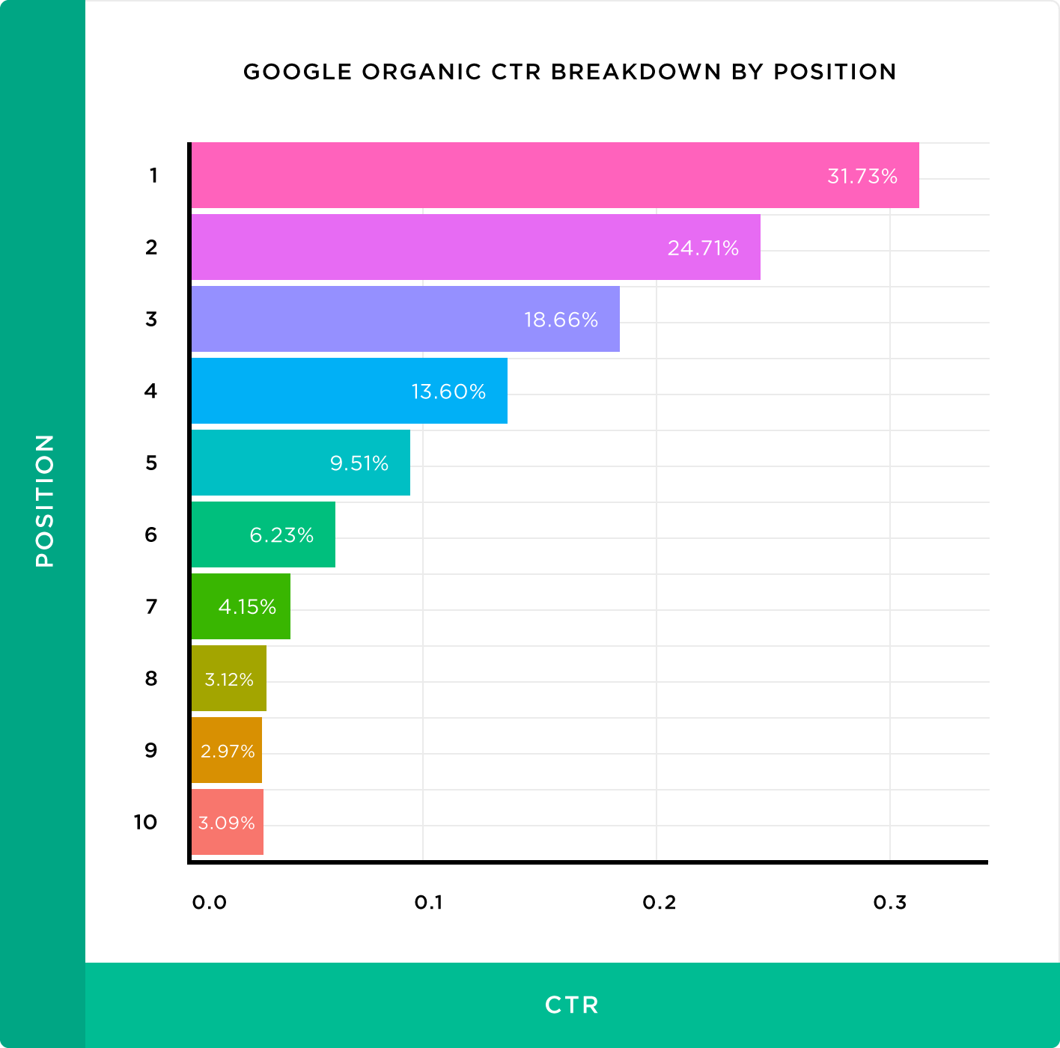

Analysing your site’s keyword traffic is essential to determine where your most valuable traffic is coming from, while performing keyword research highlights potential opportunities you may have missed.

By doing this you can refine your SEO efforts, optimise your pages and capture additional traffic from relevant searches.

If you want to estimate the SEO value of ranking at a particular position in the top 10, there is a useful formula:

SEO Value = ((OSV*CTR)*CR)*PV

Where:
OSV = organic search volume
CTR = Click Through Rate (as per the graph above depending on ranking position)
CR = Conversion Rate (average is 3% of visitors to your website)
PV = Product Value

FINDINGS

- The keyword “sell my house fast Philadelphia PA” has a monthly search volume of 200 and a keyword difficulty score of 11. This is a strong commercial-location keyword because it combines Pikeland’s core service with one of its most important target locations.
  - Moving into position 10 would generate roughly 4 visits per month.
  - Moving into position 6 would increase traffic to roughly 12 visits per month.
  - Moving into position 3 would increase traffic to roughly 37 visits per month.
  - Moving into position 1 would increase traffic to roughly 63 visits per month.
    - While the search volume is lower than broad national terms such as “sell my house fast”, the keyword difficulty is also much lower. This makes it a more realistic and commercially relevant ranking opportunity, especially because users searching with a Philadelphia modifier are more likely to be looking for a local cash home buyer.
- N/A
- N/A

RECOMMENDATIONS
- Prioritise improving the existing Philadelphia location page for this keyword.
  - Target page: https://www.pikelandpropertygroup.com/sell-your-house-fast-in-philadelphia-pa/
  - Improve the page title, H1, supporting headings, body copy, FAQs, and internal links around “sell my house fast Philadelphia PA” and close variations such as “we buy houses Philadelphia PA” and “cash home buyers Philadelphia PA”.
  - Add more Philadelphia-specific trust signals, service-area copy, seller scenarios, testimonials where available, and clear calls to action.
  - Internally link to this page from the homepage, cash offer page, process page, reviews page, and relevant blog posts using natural anchor text such as “sell your house fast in Philadelphia” or “cash home buyers in Philadelphia”.


lON PAGE SEOl

On Page SEO
In this section we look at various On Page aspects of your website which can impact SEO and user experience. We will incorporate site-wide data, where applicable.

We will focus on the following example pages for illustration:
- Home page: https://www.pikelandpropertygroup.com/
- Get your offer: https://www.pikelandpropertygroup.com/get-your-offer/
- Phoenixville (location page): https://www.pikelandpropertygroup.com/sell-your-house-fast-in-phoenixville-pa/
- Blog post: https://www.pikelandpropertygroup.com/blog/selling-your-home-to-a-direct-buyer-in-pennsylvania-3/

Page Titles

A title tag is an HTML element that specifies the title of a web page. Title tags are displayed on search engine results pages (SERPs) as the clickable headline for a given result, and are important for usability, SEO, and social sharing.
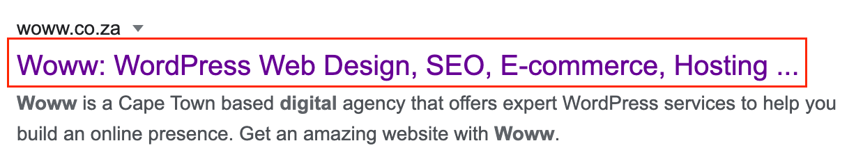

The title tag of a web page is meant to be an accurate and concise description of a page's content. You can utilize your meta description to add more creative call to actions whereas your Titles should be succinct and include the direct keywords and terms.

Moz published a useful guide on how to write a good title tag. It looks at what you should do and what to avoid.

DATA COLLECTION

 | Short titles
 | Long titles
 | Duplicate titles
 | Title suffixes

GENERAL FINDINGS

- All 74 indexable HTTP 200 pages have a page title.
- 47 indexable HTTP 200 pages have titles longer than 60 characters. This is likely to cause SERP truncation, especially on blog posts and location pages.

URL | Current title | Title length
https://www.pikelandpropertygroup.com/blog/costs-you-may-face-when-selling-your-house-pennsylvania/ | Commissions, Repairs, Marketing, and Other Potential Costs You May Face When Selling Your House in Pennsylvania - Pikeland Property Group | 137
https://www.pikelandpropertygroup.com/blog/selling-a-property-that-needs-repairs-in-pennsylvania/ | 6 Things You Need to Know About Selling a Property That Needs Repairs in Pennsylvania - Pikeland Property Group | 111
https://www.pikelandpropertygroup.com/get-a-cash-offer-today/ | Sell My House Fast Philadelphia - We Buy Houses for Cash - Pikeland Property Group | 82

- 16 indexable HTTP 200 pages sit within duplicate title groups. The most important issue is the location page template. 10 location pages use the same title:
  - “Sell My House Fast Pennsylvania [market_state] - We buy houses in Pennsylvania - Pikeland Property Group”
  - This includes important local pages such as Philadelphia, Wilmington, Reading, York, Lancaster, Pottstown, Phoenixville, Coatesville, Upper Darby, and Pittsburgh. The title also contains the unresolved placeholder “[market_state]”, which makes the title look unfinished and prevents each location page from targeting its specific city/state properly.
- Some important commercial pages have titles that are too generic. The Get Your Offer page title is “Get Your Offer - Pikeland Property Group”. The Compare page title is “Compare - Pikeland Property Group”. The Reviews page title is “Reviews - Pikeland Property Group”. These pages are indexable and commercially useful, but their titles do not clearly target terms such as cash offer, cash home buyers, trusted home buyers, or cash buyer comparison.
- N/A

GENERAL RECOMMENDATIONS
- Rewrite duplicate location page titles first. Each indexable location page should have a unique title that includes the specific city or state being targeted. Remove the “[market_state]” placeholder from all live page titles.
Page type | Example improved title
Philadelphia location page | Sell My House Fast Philadelphia PA | Pikeland Property Group
Wilmington location page | We Buy Houses in Wilmington DE | Pikeland Property Group
Reading location page | Cash Home Buyers in Reading PA | Pikeland Property Group

- Shorten long blog titles so the main keyword and value are visible in search results. Keep titles closer to 55-60 characters where possible. Put the main topic first and remove unnecessary wording.
Current issue | Example improved title
Long cost article title | Costs of Selling a House in Pennsylvania | Pikeland
Long repairs article title | Selling a House As-Is in Pennsylvania | Pikeland
Long direct buyer title | Selling to a Direct Buyer in Pennsylvania | Pikeland

- Improve generic commercial page titles.
URL | Current title | Example improved title
https://www.pikelandpropertygroup.com/get-your-offer/ | Get Your Offer - Pikeland Property Group | Get a Cash Offer for Your House | Pikeland
https://www.pikelandpropertygroup.com/compare/ | Compare - Pikeland Property Group | Compare Cash Home Buyers vs Realtors | Pikeland
https://www.pikelandpropertygroup.com/reviews/ | Reviews - Pikeland Property Group | Pikeland Property Group Reviews | Trusted Home Buyers

- https://www.pikelandpropertygroup.com/sell-house-awn/ share the same title. The Get a Cash Offer Today page and Resource Page share the same title.
  - The two Thank You pages share the same title.
    - If these pages need to remain indexable, give each one a unique title that describes its specific purpose. If they do not need to rank, consider whether they should be noindexed.

HOME PAGE FINDINGS: https://www.pikelandpropertygroup.com/
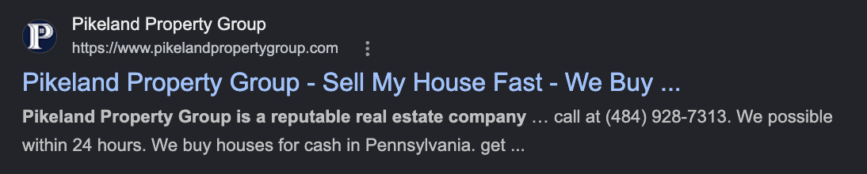

- The homepage has an indexable HTTP 200 page title.

Current title | Title length
Pikeland Property Group - Sell My House Fast - We Buy Houses for Cash | 69

- The title is slightly too long and may be truncated in search results.
  - The title includes relevant commercial terms such as “Sell My House Fast” and “We Buy Houses for Cash”, which is positive because these match Pikeland’s core service.
  - The title is duplicated with another indexable page: https://www.pikelandpropertygroup.com/sell-house-awn/. This creates a duplicate title issue and makes it less clear which page should be treated as the primary homepage/commercial landing page.
- N/A

RECOMMENDATIONS
- Rewrite the homepage title so it remains commercially focused but is more concise.
  - Suggested title: Sell My House Fast for Cash | Pikeland Property Group
  - Keep the homepage as the primary target page for broad commercial terms such as “sell my house fast”, “we buy houses”, and “sell my house for cash”.
    - Review whether https://www.pikelandpropertygroup.com/sell-house-awn/ should remain indexable. If it is not needed as a separate landing page, consider noindexing, redirecting, or canonicalising it to the homepage.

GET YOUR OFFER PAGE FINDINGS: https://www.pikelandpropertygroup.com/get-your-offer/
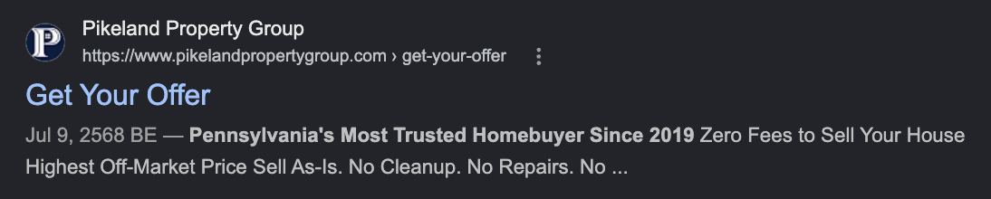

- The Get Your Offer page has an indexable HTTP 200 page title.

Current title | Title length
Get Your Offer - Pikeland Property Group | 40

- The title is not too long and is not duplicated, which is positive.
- The title may be too generic for an important conversion page. It does not clearly describe the cash offer purpose of the page or target relevant terms such as “cash offer for my house”, “get cash offer for house”, or “free cash offer”.
  - Because this page is intended to generate enquiries, the title should make the page’s commercial purpose clearer in search results.
- n/a

RECOMMENDATIONS
- Rewrite the title so it targets cash offer intent more directly.
  - Suggested title: Get a Cash Offer for Your House | Pikeland
  - Use the page to support cash offer keywords and related messaging around no-obligation offers, no repairs, no fees, and flexible closing.
    - Internally link to this page from the homepage, process page, location pages, and relevant blog posts using natural anchor text such as “get a cash offer” or “get a cash offer for your house”.

PHOENIXVILLE PAGE FINDINGS: https://www.pikelandpropertygroup.com/sell-your-house-fast-in-phoenixville-pa/
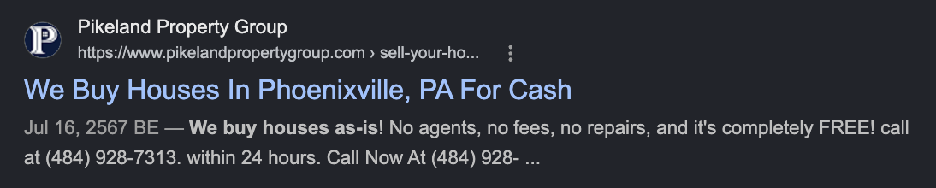

- The Phoenixville page has an indexable HTTP 200 page title.

Current title | Title length
Sell My House Fast Pennsylvania [market_state] - We buy houses in Pennsylvania - Pikeland Property Group | 104

- The title is too long and likely to be truncated in search results.
  - The title is duplicated across 10 location pages, including Philadelphia, Wilmington, Reading, York, Lancaster, Pottstown, Phoenixville, Coatesville, Upper Darby, and Pittsburgh.
  - The title contains the unresolved placeholder “[market_state]”, which makes the title look unfinished.
  - The title does not clearly target Phoenixville, even though the page URL and H1 are specific to Phoenixville.
- N/A

RECOMMENDATIONS
- Rewrite the Phoenixville page title so it is unique and location-specific.
  - Suggested title: Sell My House Fast Phoenixville PA | Pikeland
  - Alternative title: We Buy Houses in Phoenixville PA | Pikeland
  - Remove the “[market_state]” placeholder from all location page titles.
    - Use a unique title for every indexable location page so each page targets its own city or service area.

BLOG POST FINDINGS: https://www.pikelandpropertygroup.com/blog/selling-your-home-to-a-direct-buyer-in-pennsylvania-3/
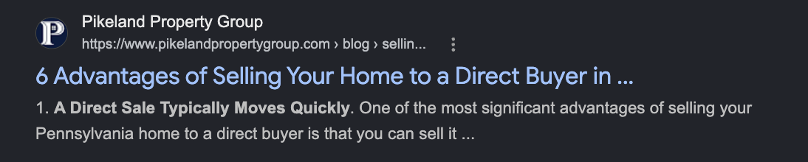

- The blog post has an indexable HTTP 200 page title.

Current title | Title length
6 Advantages of Selling Your Home to a Direct Buyer in Pennsylvania That You Might Not Know About - Pikeland Property Group | 123

- The title is too long and likely to be heavily truncated in search results.
  - The title describes the article topic, but the main intent is diluted by unnecessary wording.
  - The phrase “That You Might Not Know About” adds length without adding much SEO value.
- This post also sits within a wider group of direct buyer articles, so the title should be more concise and differentiated from similar direct buyer content.
- N/A

RECOMMENDATIONS
- Shorten the title so the main topic is visible in search results.
- Suggested title: Selling Home to a Direct Buyer in Pennsylvania: 6 Benefits
  - Alternative title: 6 Benefits of Selling Your Home to a Direct Buyer in PA
  - Review this post against other direct buyer articles to make sure each one has a distinct purpose and title.
    - Internally link the post to the Compare page, Reviews page, Get Your Offer page, and relevant location pages.

Meta Descriptions

The meta description is a snippet of up to about 155 characters – a tag in HTML – which summarizes a page’s content. Search engines show the meta description in the search results.

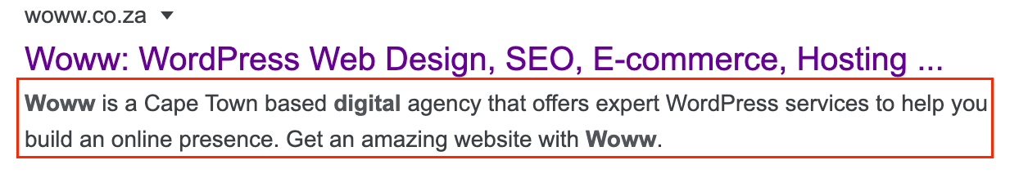

Generally, the searched-for phrase shows up within the meta description, so optimizing the meta description is crucial for on-page SEO.

Studies have lately shown that metas don’t affect SEO as much as they do user click through rates. Optimization of your metas descriptions will provide the user with a better chance of clicking if it matches their intent.

Meta descriptions are not a big ranking factor any longer, but you can try to use this section as an opportunity to convert users or give them a snippet of the information they may be looking for (pricing, list of items required, or location) - this encourages users to click through and read more.

Click Through Rate is however a ranking factor, so maximising CTR through meta descriptions makes meta descriptions a ranking factor by proxy.

DATA COLLECTION

 | Missing metas
 | Long metas
 | Short metas
 | Duplicate metas

GENERAL FINDINGS

- 0 pages have short meta descriptions.
- n/a
- 11 indexable HTTP 200 pages are missing meta descriptions. These are mainly blog/category/archive pages, including the main Blog page, FAQ archive pages, category pages, and author archive pages.

Example URL | Issue
https://www.pikelandpropertygroup.com/blog/ | Missing meta description
https://www.pikelandpropertygroup.com/blog/category/sellers/ | Missing meta description
https://www.pikelandpropertygroup.com/blog/faq-items/ | Missing meta description
https://www.pikelandpropertygroup.com/blog/author/harrisonpikelandpropertygroup-com/ | Missing meta description

- 62 indexable HTTP 200 pages have meta descriptions that are too long. Many descriptions appear to be pulled from page body copy rather than written as concise SERP snippets, so they are likely to be truncated in search results.
URL | Current length
https://www.pikelandpropertygroup.com/our-company/ | 350
https://www.pikelandpropertygroup.com/reviews/ | 306
https://www.pikelandpropertygroup.com/get-your-offer/ | 292
https://www.pikelandpropertygroup.com/blog/selling-your-home-to-a-direct-buyer-in-pennsylvania-3/ | 233

- 14 indexable HTTP 200 pages have more than one meta description. This can make it unclear which description Google should use and may reduce control over SERP snippets.
Example URL | Lengths
https://www.pikelandpropertygroup.com/ | 244 and 227
https://www.pikelandpropertygroup.com/sell-your-house-fast-in-phoenixville-pa/ | 189 and 104
https://www.pikelandpropertygroup.com/sell-your-house-fast-in-philadelphia-pa/ | 189 and 116
https://www.pikelandpropertygroup.com/get-a-cash-offer-today/ | 64 and 273

- 2 duplicate meta description groups affect 4 indexable HTTP 200 pages.
URLs | Issue
https://www.pikelandpropertygroup.com/get-your-offer/ and https://www.pikelandpropertygroup.com/house-information/ | Both use the same 292-character cash offer description
https://www.pikelandpropertygroup.com/privacy-policy/ and https://www.pikelandpropertygroup.com/terms-of-user/ | The Terms of Use page appears to reuse the Privacy Policy description

GENERAL RECOMMENDATIONS
- Write unique meta descriptions for important indexable pages that are missing them, especially the Blog page, FAQ archive, and any category/archive pages that should remain indexable.
  - Rewrite long meta descriptions so they are closer to 100-140 characters where possible. Each description should summarise the page, include the core topic naturally, and give users a reason to click.
  - Remove duplicate or multiple meta descriptions from important pages so each indexable page has one clear, controlled SERP description.
  - Prioritise commercially important pages first, including the homepage, Get Your Offer page, key location pages, Reviews page, Compare page, and high-value blog posts.
- Review whether archive and utility pages should remain indexable. If they are not intended to rank, consider noindexing them rather than writing custom meta descriptions.

HOME PAGE FINDINGS: https://www.pikelandpropertygroup.com/


- N/A
- The homepage has two meta descriptions.
  - Both descriptions include useful commercial messaging, but they are too long for a controlled SERP snippet.
  - Having two meta descriptions means Google may choose between them or create its own snippet, reducing control over how the homepage appears in search results.

Current meta description | Length | Issue
We can purchase homes in as little as 7 days for those needing a quick solution. We have helped homeowners out of situations such as probate, inheritance, fire damage, foreclosure, tenant damage, evictions, foundation problems and so much more. | 244 | Too long
Sell Your House For Cash Get A Fair Cash Offer from Your #1 Local, Trusted Cash Home Buyer. No Realtors, No Fees, No Repairs. Pennsylvania’s Trusted Home Buyer since 2019 Real Clients. Real Testimonials. Keep reading to see why | 227 | Too long

- N/A

RECOMMENDATIONS
- Keep one homepage meta description only, and ensure it is below 140 characters long.
  - Suggested meta description: Sell your Pennsylvania house fast for cash. No repairs, no realtor fees, and flexible closing with Pikeland Property Group.

GET YOUR OFFER PAGE FINDINGS: https://www.pikelandpropertygroup.com/get-your-offer/


- The Get Your Offer page has one meta description.
Current meta description | Length | Issue
Get Your Free Cash Offer Pennsylvania's Most Trusted Homebuyer Since 2019 Zero Fees to Sell Your House Highest Off-Market Price Sell As-Is. No Cleanup. No Repairs. No Closing Costs No Realtors No Showings Real Clients. Real Testimonials. See why we are a top-rated home buyer in Pennsylvania. | 292 | Too long
- The description is relevant to the page because it mentions a free cash offer, no fees, selling as-is, no repairs, no closing costs, no realtors, no showings, and testimonials.
  - However, it is too long and reads like several selling points joined together rather than a concise search result description.
  - The same description is also used on https://www.pikelandpropertygroup.com/house-information/, creating a duplicate meta description issue.
- n/a

RECOMMENDATIONS
- Rewrite the Get Your Offer meta description so it is concise and clearly conversion-focused.
  - Suggested meta description: Get a free cash offer for your Pennsylvania house. Sell as-is with no repairs, no realtor fees, and flexible closing.

PHOENIXVILLE PAGE FINDINGS: https://www.pikelandpropertygroup.com/sell-your-house-fast-in-phoenixville-pa/


- n/a
- The Phoenixville page has two meta descriptions.

Current meta description | Length | Issue
Need to sell your house fast? We buy houses in Pennsylvania, [market_state] and surrounding areas in as little as 7 days. If you're saying "I need to sell my house fast!", we'd like to buy! | 189 | Too long and contains “[market_state]”
We Buy Houses In Phoenixville, PA For Cash Get A Fair Cash Offer Today No Realtors, No Fees, No Repairs. | 104 | Better length, but competing with another meta description

- The first description uses a templated location-page format and still contains the unresolved “[market_state]” placeholder.
  - The second description is more relevant to Phoenixville, but because the page has multiple meta descriptions, Google may not use the preferred one consistently.
- N/A

RECOMMENDATIONS
- Keep one Phoenixville-specific meta description only.
  - Suggested meta description: Sell your house fast in Phoenixville, PA. Get a fair cash offer with no repairs, no realtor fees, and flexible closing.

BLOG POST FINDINGS: https://www.pikelandpropertygroup.com/blog/selling-your-home-to-a-direct-buyer-in-pennsylvania-3/


- The blog post has one meta description.
Current meta description | Length | Issue
Selling a home in Pennsylvania is a major decision that affects your life in many ways. Whether you are downsizing, relocating, or looking for a change, finding the right buyer for your property is essential. While some people prefer | 233 | Too long and cuts off mid-thought

- The current description introduces the topic of selling to a direct buyer in Pennsylvania, but it ends mid-thought with “While some people prefer”.
  - This suggests the meta description may have been pulled from the opening paragraph rather than written manually.
- N/A

RECOMMENDATIONS
- Rewrite the blog post meta description so it summarises the article clearly and fits within a shorter SERP-friendly range.
  - Suggested meta description: Learn the benefits of selling your Pennsylvania home to a direct buyer, including faster closing, fewer repairs, and a simpler sale.

OG Tags & Twitter Cards

The open graph (OG) protocol allows developers to leverage Facebook in new and exciting ways. One of the easiest ways to venture into the world of Open Graph is to add the open graph meta tags to your site.

Open graph meta tags allow you to control what content shows up when a page is shared on Facebook. Twitter offers a similar function with Twitter Open Card Tags.

The most important OG tag attributes and Twitter Card attributes to have are: title, image, and description (as these are the attributes that the user will notice when scrolling).

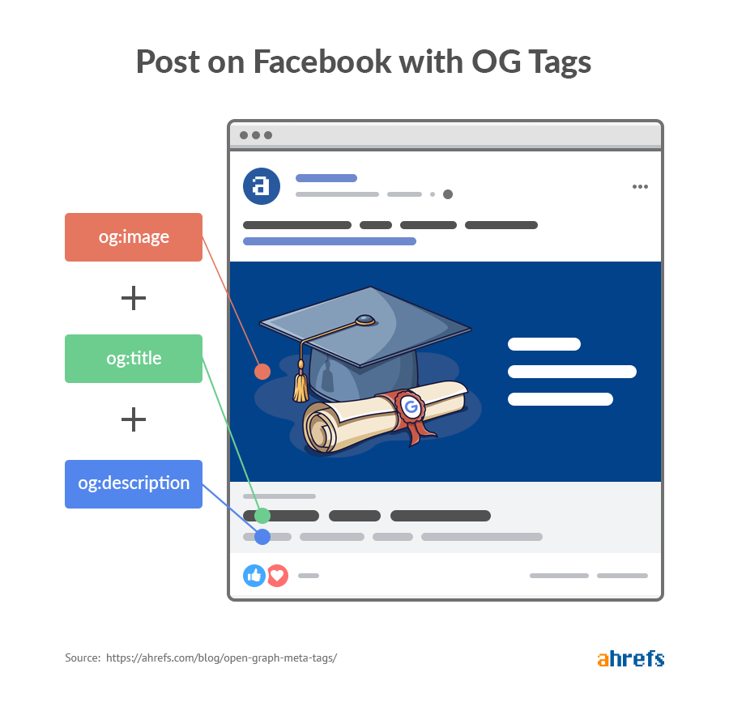

FINDINGS: OG Tags

- All 74 indexable HTTP 200 pages have valid Open Graph data recorded in the crawl.
- The issue is quality and control rather than missing implementation. Important pages output duplicated Open Graph attributes, including repeated og:image, og:url, og:title, og:site_name, og:type, and og:locale fields.
  - Several key pages use long, meta-description-style OG descriptions, meaning shared previews may appear cluttered or be cut off.
  - Location pages inherit title and description issues already identified in the page title and meta description sections. For example, the Phoenixville page uses Sell My House Fast Pennsylvania [market_state] - We buy houses in Pennsylvania - Pikeland Property Group as its OG title, and one OG description still contains [market_state].
  - Many pages use the same fallback image, pikeland-property-group-cover.png, which reduces the ability for important commercial, location, and blog pages to have tailored social previews.

URL | Current OG issue
https://www.pikelandpropertygroup.com/ | The homepage has two OG image sets and two OG descriptions. One description starts Sell Your House For Cash Get A Fair Cash Offer...; the other starts We can purchase homes in as little as 7 days....
https://www.pikelandpropertygroup.com/get-your-offer/ | The page has duplicated OG fields and uses a long OG description: Get Your Free Cash Offer Pennsylvania's Most Trusted Homebuyer Since 2019 Zero Fees to Sell Your House...
https://www.pikelandpropertygroup.com/sell-your-house-fast-in-phoenixville-pa/ | The OG title contains [market_state], and one OG description says Need to sell your house fast? We buy houses in Pennsylvania, [market_state] and surrounding areas...
https://www.pikelandpropertygroup.com/blog/selling-your-home-to-a-direct-buyer-in-pennsylvania-3/ | The OG title is too long and the OG description cuts off mid-thought: Selling a home in Pennsylvania is a major decision... While some people prefer

- n/a

FINDINGS: Twitter Cards

- All 74 indexable HTTP 200 pages have valid X/Twitter Card data recorded in the crawl.
- Twitter Card implementation is basic. Most pages use summary_large_image, but many do not have dedicated twitter:title, twitter:description, or twitter:image fields, so X may rely on the Open Graph data instead.
  - Because Twitter previews often fall back to OG values, the duplicated OG titles, descriptions, and image issues may also affect X/Twitter previews.
  - Some blog and FAQ pages include reading-time metadata, but key commercial pages should prioritise clear preview titles, descriptions, and images rather than secondary metadata.
- n/a.

RECOMMENDATIONS
- Sitewide OG cleanup: Keep one clean set of Open Graph tags per page. Each indexable page should have a single og:title, og:description, og:image, og:url, og:type, and og:site_name.
- Priority commercial pages: Prioritise the homepage, Get Your Offer page, Philadelphia page, Phoenixville page, and other location pages because these are more likely to be shared by prospects, partners, and local users.
- Location pages: Rewrite OG titles and descriptions so each location page uses the correct city/state and removes [market_state].
- Images: Use a consistent branded image for broad pages, but create more specific preview images for priority location pages and important blog articles where possible.
- Twitter Cards: Add dedicated twitter:title, twitter:description, and twitter:image fields for important pages instead of relying only on twitter:card and OG fallback data.
- Blog posts: Shorten blog OG titles and descriptions so shared previews communicate the article topic clearly without cutting off mid-sentence.
- Validation: After updates, retest priority URLs with Facebook Sharing Debugger and X Card Validator or a similar preview tool to confirm the correct title, description, image, and URL are being pulled.

H-Tag Heading Structure
Assistive technologies such as screen readers use heading tags (h1-h6) to give visitors an overview of a page without the need for them to read through the entire content.

Search engines can read headings to determine the importance of page sections. They can then use this information to gauge the page's 'weight' for the search engine listings.

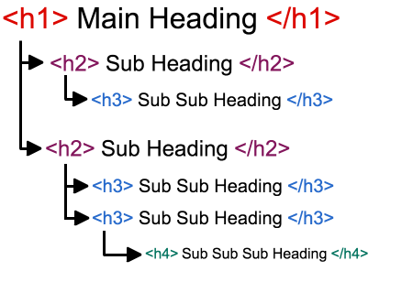
You can view headings and test this using this tool: http://www.seowebpageanalyzer.com/

DATA COLLECTION

 | Pages with multiple h1s
 | Pages missing h1s
 | Pages with the same h1
 | H2s

GENERAL FINDINGS

- 73 of the 74 indexable pages have one h1 set.
- 1 indexable HTTP 200 page is missing an H1: https://www.pikelandpropertygroup.com/terms-of-user/. This is a low-priority legal page, but it should still have a clear H1 if it remains indexable.
- 6 duplicate H1 groups affect 12 indexable HTTP 200 pages. The most important duplicate groups are Sell Your House For Cash, used on the homepage and /sell-house-awn/, and Get Your Free Cash Offer, used on /get-your-offer/ and
- The heading structure is not consistently aligned with the keyword opportunities identified in the keyword research.
  - Priority pages often have usable H1s, but the supporting H2/H3 structure does not fully reinforce commercial themes such as selling fast, selling for cash, selling as-is, no repairs, no fees, and local service coverage.
- The homepage H1, Sell Your House For Cash, is relevant but broad.
  - It does not fully reflect the strongest commercial keyword opportunities, including sell my house fast (26,000 vol / KD 3), sell my house for cash (10,000 vol / KD 52), and we buy houses pennsylvania (800 vol / KD 26).
- Location pages have stronger local H1s than their page titles and meta descriptions.
  - The Phoenixville page has a locally relevant H1, but the title, meta descriptions, and supporting headings are not fully aligned.
    - The current H1 is We Buy Houses In Phoenixville, PA For Cash, which is suitable for local cash buyer intent.
    - However, the current page title is Sell My House Fast Pennsylvania [market_state] - We buy houses in Pennsylvania - Pikeland Property Group, which still contains the placeholder [market_state] and does not properly target Phoenixville. The page also has two meta descriptions
- Some blog headings are structurally clear, but they do not always support the informational keyword opportunities identified in the keyword research, such as sell house as is (1,700 vol / KD 15), sell house as is for cash (1,000 vol / KD 13), how to sell a house as is (700 vol / KD 24), and cost-related queries such as cost of selling a house (900 vol / KD 6).
- Template headings such as Archives, Categories, and The best way to sell your house fast. appear in the heading structure on blog pages. These dilute the topical structure and do not support the informational or commercial intent of the article.
- n/a

GENERAL RECOMMENDATIONS
- Commercial page alignment: Align H1s, H2s, page titles, and meta descriptions around the same primary intent. The homepage should reinforce fast cash sale intent, the offer page should support conversion intent, and location pages should reinforce local cash buyer intent.
- Homepage Heading Structure: Strengthen the homepage headings around the core commercial keyword set. The H1 should target the broader cash home buyer proposition, while H2s should support selling fast, selling as-is, no repairs, no fees, process, trust, and service areas.
- Location page Heading Structure: Keep locally relevant H1s such as We Buy Houses In Phoenixville, PA For Cash, but restructure repetitive H2s so they support the local search opportunity more clearly. Each location page should cover process, benefits, as-is sales, cash sale advantages, trust signals, and local FAQs.
- Blog heading structure: Use blog H1s and H2s to better target informational keyword opportunities. Existing posts should be overhauled where they already match a keyword theme, rather than creating new articles unnecessarily.
- Template headings: Remove, demote, or exclude sidebar and CTA headings from the main heading structure where possible, especially Archives, Categories, and generic CTA text.
- Missing H1 (low priority): Add an H1 to the Terms of Use page if it remains indexable. This is low priority, but it keeps the indexable page template technically consistent.

HOME PAGE FINDINGS: https://www.pikelandpropertygroup.com/
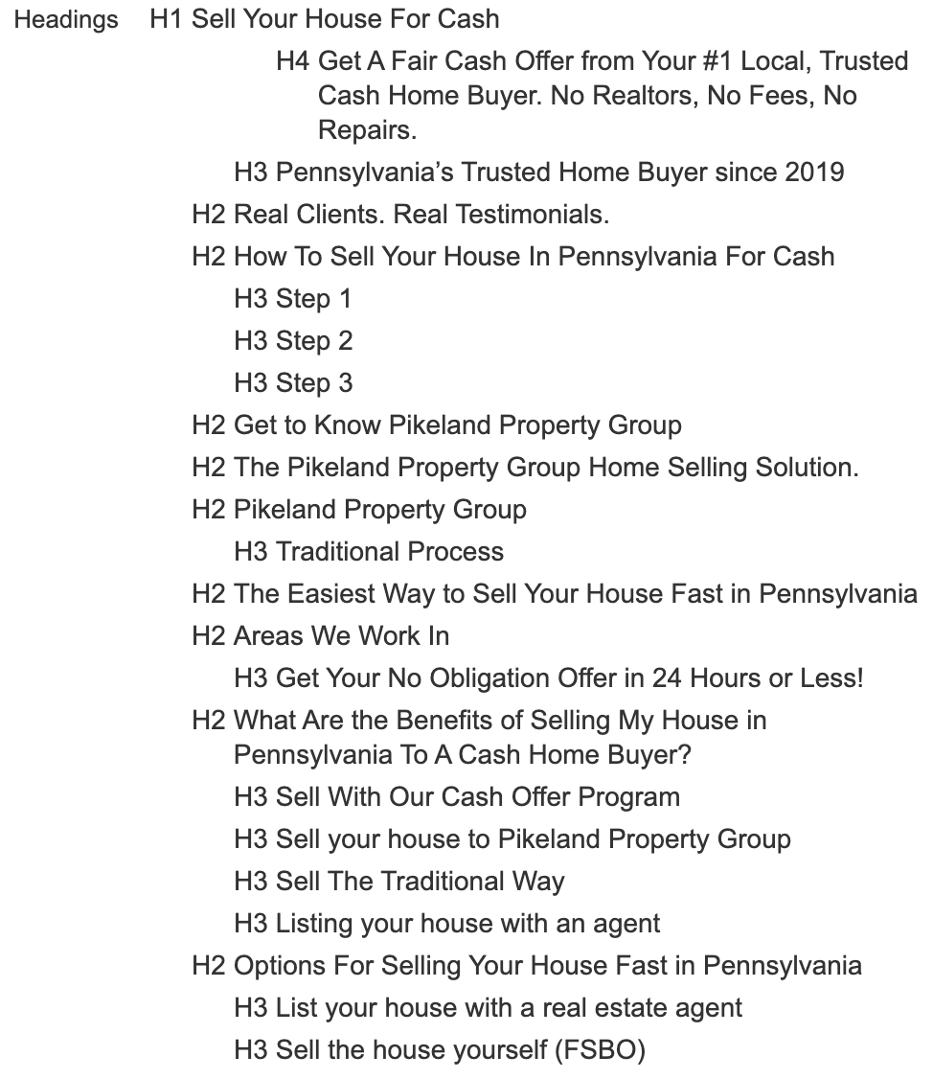 | 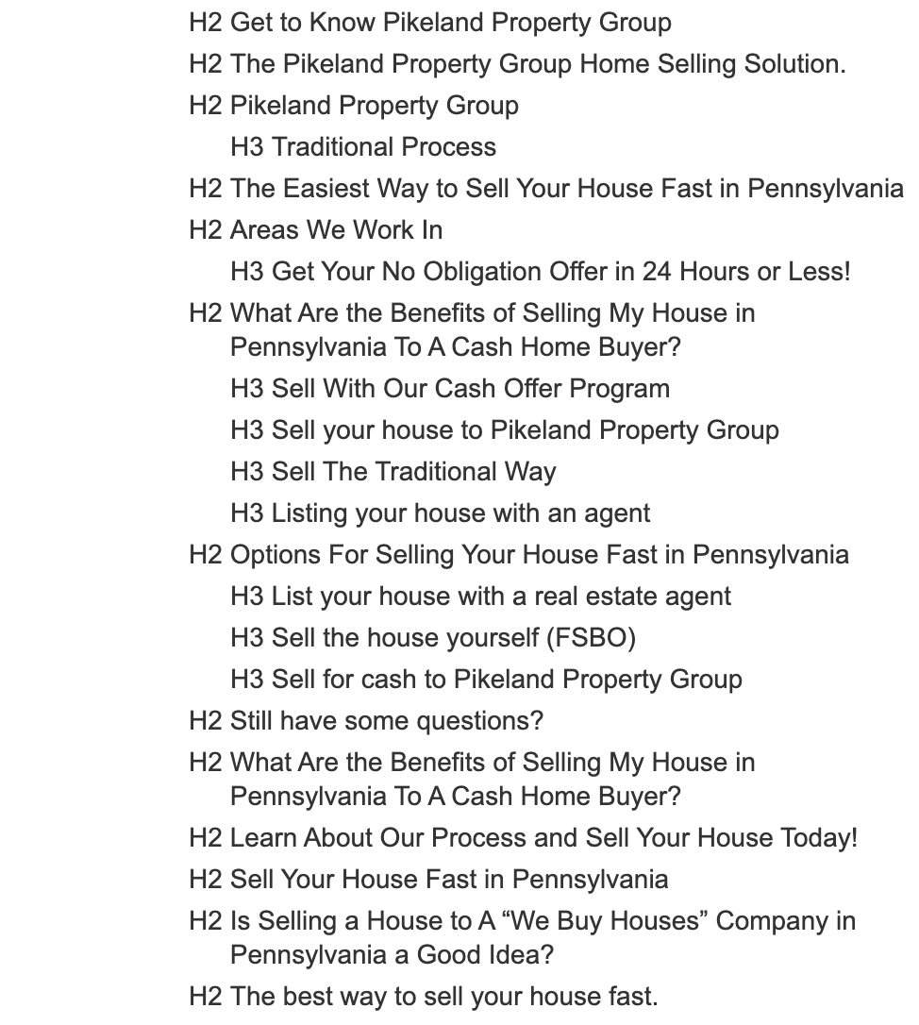

- The H1 is relevant, but it does not fully capture the higher-value commercial opportunity around fast cash house selling in Pennsylvania.
  - H1: Sell Your House For Cash
- These headings are directionally strong and align but lean more informationa. The page may benefit from a clearer commercial aligned hierarchy around fast sale, cash offer, as-is sale, no fees, and local service coverage.
Headings focused on these areas are positioned lower down in the heading structure (h3s).
  - H2 examples: How To Sell Your House In Pennsylvania For Cash, The Easiest Way to Sell Your House Fast in Pennsylvania, Areas We Work In
- The repeated heading creates duplication and should be consolidated into one stronger benefits section.
  - Repeated H2: What Are the Benefits of Selling My House in Pennsylvania To A Cash Home Buyer?
- n/a

RECOMMENDATIONS
- Change the H1 to better reflect the commercial opportunity. Suggested H1: Sell Your House Fast for Cash in Pennsylvania.
  - sell my house fast (26,000 vol / KD 3), sell my house for cash (10,000 vol / KD 52), we buy houses pennsylvania (800 vol / KD 26)
- Add H2s that support the cash buyer proposition, such as How Our Cash Home Buying Process Works, Sell Your House As-Is With No Repairs, No Realtor Fees or Commissions, and Areas We Buy Houses In.
  - cash home buyers (8,300 vol / KD 34), cash for houses (6,000 vol / KD 15)
- Make sure the revised H1 supports the recommended homepage title and meta description, so the page sends one consistent signal around selling a Pennsylvania house fast for cash.

GET YOUR OFFER PAGE FINDINGS: https://www.pikelandpropertygroup.com/get-your-offer/
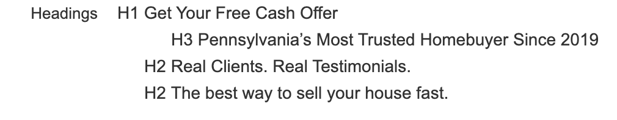

- The H1 is appropriate for the page’s conversion purpose and supports cash offer intent.
  - H1: Get Your Free Cash Offer
- This is a useful trust statement, but it should sit within a clearer page hierarchy rather than carrying the structure on its own. It creates a jump in heading level hierarchy.
  - H3: Pennsylvania’s Most Trusted Homebuyer Since 2019
- The supporting H2 structure is thin for such an important conversion page and does not fully support the keyword themes from the recommendations.
  - H2s: Real Clients. Real Testimonials. and The best way to sell your house fast.
- n/a

RECOMMENDATIONS
- Keep or slightly refine the H1.
  - Suggested H1: Sell my house for cash
  - Support it with an H2: Get a Free Cash Offer for Your House.
    - sell my house for cash (10,000 vol / KD 52), cash home buyers (8,300 vol / KD 34), cash for houses (6,000 vol / KD 15)
- Add H2s such as How the Cash Offer Process Works, Sell As-Is With No Repairs, No Realtor Fees or Commissions, and Choose Your Closing Date.
- Align the H1 and H2s with the recommended page title and meta description so the offer page consistently supports a free cash offer conversion journey.

PHOENIXVILLE PAGE FINDINGS: https://www.pikelandpropertygroup.com/sell-your-house-fast-in-phoenixville-pa/
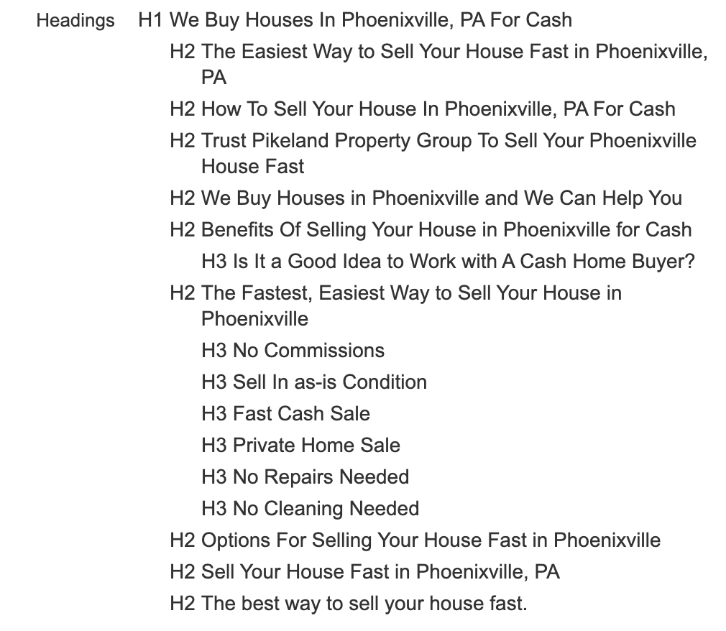
- Keep the current H1, We Buy Houses In Phoenixville, PA For Cash, because it clearly targets local cash buyer intent. Update the title and meta description so they match the H1 and remove [market_state]. Suggested title: `We Buy Houses in Phoenixville PA
- The H2s support the local commercial intent, but they are repetitive. The page needs clearer sections that expand the topic rather than restating the same keyword angle.
  - H2 examples: The Easiest Way to Sell Your House Fast in Phoenixville, PA, How To Sell Your House In Phoenixville, PA For Cash, Trust Pikeland Property Group To Sell Your Phoenixville House Fast
- These are useful benefit-led subheadings and should be kept under a stronger benefits section.
  - H3 examples: No Commissions, Sell In as-is Condition, Fast Cash Sale, No Repairs Needed
- n/a

RECOMMENDATIONS
- Keep the H1 because it clearly targets local cash buyer intent.
  - H1: We Buy Houses In Phoenixville, PA For Cash
- Restructure the H2s to reduce repetition. Suggested H2s include How to Sell Your House Fast in Phoenixville, Sell Your Phoenixville House As-Is, Why Work With Pikeland Property Group, Benefits of a Cash Home Sale, and Phoenixville Home Seller FAQs.
  - Align with local “sell house fast” intent more closely

BLOG POST FINDINGS: https://www.pikelandpropertygroup.com/blog/selling-your-home-to-a-direct-buyer-in-pennsylvania-3/
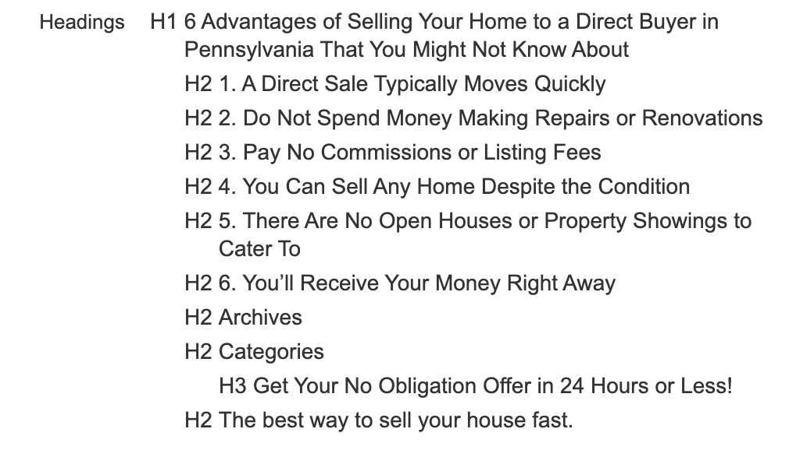
- n/a
- The H1 is descriptive but too long. It could better support the recommendation to consolidate and strengthen direct buyer content.
  - H1: 6 Advantages of Selling Your Home to a Direct Buyer in Pennsylvania That You Might Not Know About
- The article’s main H2s are logically structured and support direct buyer intent, but the post should be improved as part of the wider recommendation to consolidate overlapping direct buyer articles.
  - H2s: 1. A Direct Sale Typically Moves Quickly, 2. Do Not Spend Money Making Repairs or Renovations, 3. Pay No Commissions or Listing Fees, 4. You Can Sell Any Home Despite the Condition, 5. There Are No Open Houses or Property Showings to Cater To, 6. You’ll Receive Your Money Right Away
- These template headings weaken the article structure and do not support the target informational/commercial topic.
  - H2s: Archives, Categories, The best way to sell your house fast.
- n/a

RECOMMENDATIONS
- Shorten the H1 to 6 Benefits of Selling to a Direct Buyer in Pennsylvania or Selling to a Direct Buyer in Pennsylvania: 6 Benefits.
- When overhauling or consolidating the direct buyer articles, add H2s that answer related seller questions around selling as-is, avoiding repairs, avoiding commissions, and comparing a direct buyer with a traditional sale.
  - sell house as is (1,700 vol / KD 15), sell house as is for cash (1,000 vol / KD 13), how to sell a house as is (700 vol / KD 24)
- Use this post as part of the wider direct-buyer consolidation work rather than treating it as a standalone heading fix. The heading structure should support the recommended strategy of strengthening trust, comparison, as-is selling, and cash sale angles.
- Remove or demote Archives, Categories, and generic CTA headings from the main article hierarchy.

Media, Images and Alt Text
The images you use say a lot about your content. Unfortunately, Google is really bad at understanding what images are.

To help with this problem you want to use Alt Text, which are tags that describe the appearance and function of images on your page.

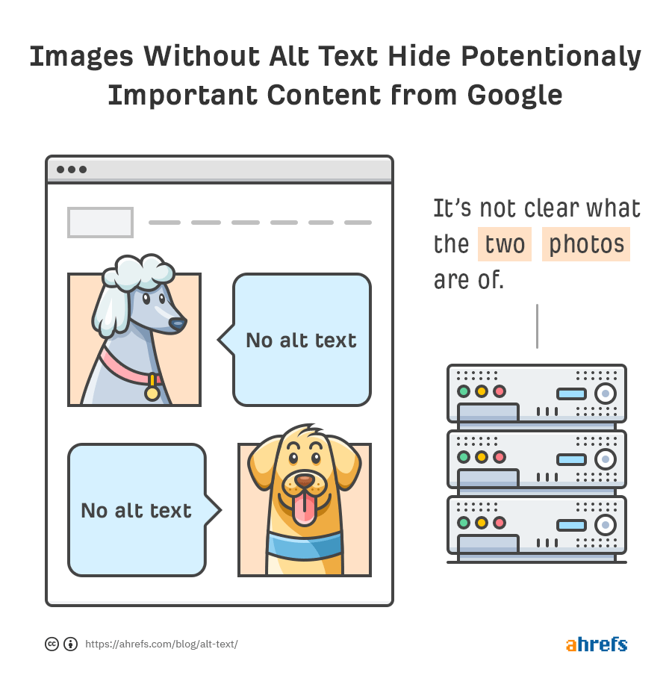

Optimal Alt text is descriptive but doesn’t contain spammy keywords.

Here’s an example to better understand how you should write alt text tags for your images.

<img src="waffle.png"

Okay: “waffle”
Good: “stack of waffles with strawberries and powdered sugar”
Not recommended:
Blank " " or “waffle waffles breakfast food best breakfast top breakfasts breakfast recipes waffle recipe"

For more information on alt tags, Moz has written helpful guidelines on what to do and what to avoid.

DATA COLLECTION

 | Unique images
 | Unique alt text

GENERAL FINDINGS

- Key recurring brand assets have usable alt text in some cases. For example, the logo commonly uses Pikeland Property Group Logo, which is appropriate for a branded image.
- 930 image instances were found on indexable HTTP 200 pages. 356 of these have blank alt attributes. When limited to content images, 169 content image instances are missing alt text.
- 42 unique image URLs have at least one missing alt text instance. This includes images used on priority commercial pages, location pages, and blog/category pages.
- Missing alt text weakens the page-level targeting already identified in the keyword research. Images on pages targeting themes such as sell my house fast, sell my house for cash, cash home buyers, sell house as is, and local “we buy houses” queries should support those topics naturally where the image is meaningful.
- Some alt text is too generic. For example, House For Sale appears 20 times, but this does not describe the page-specific context, such as a cash home sale, as-is sale, no-repairs sale, or local Pennsylvania/Phoenixville house selling intent.
- Several repeated visual assets are missing alt text, including need-to-sell-my-house-fast.webp, which appears 9 times with blank alt text, and circle-check.png, which appears 10 times with blank alt text.
- Some important image filenames are useful but not fully supported by alt text. For example, filenames such as philly-cash-home-buyer.webp and need-to-sell-my-house-fast.webp are aligned with keyword themes, but the missing alt attributes reduce their SEO and accessibility value.
- The Phoenixville page screenshot shows images not displaying correctly on the page, with error messages shown for two images. This affects user experience and weakens the trust signals on an important local landing page.

GENERAL RECOMMENDATIONS
- Correct instances of missing alt text:
  - Add descriptive alt text to meaningful content images on indexable pages. Prioritise the homepage, Get Your Offer page, location pages, and blog posts that are being optimised or overhauled from the keyword research recommendations.
- Improve keyword alignment (offer & location based pages):
  - Use natural, descriptive alt text that supports the page topic without keyword stuffing. For example, an image on a cash buyer page can reference a cash home sale or selling a house fast for cash if that accurately describes the image.
  - Use local context where relevant. Images on Phoenixville, Philadelphia, Reading, Wilmington, and other location pages should support local selling intent where the image genuinely relates to the location or service.
- Add alt text to blog images:
  - In order to support the informational opportunities previously identified, especially around selling as-is, selling with no repairs, direct buyers, costs, inherited homes, fire damage, and vacant/abandoned properties.
- Replace generic alt text:
  - Such as House For Sale with more specific descriptions when the image is meaningful. Decorative icons can use empty alt text if they do not add information.
- Fix broken images:
  - Fix images that are not displaying, especially on the Phoenixville page. Broken or unloaded images reduce trust and make local landing pages feel less polished.
- Improve file naming:
  - When images are replaced or re-uploaded, use descriptive filenames that support the topic, such as cash-home-buyer-philadelphia.webp, sell-house-as-is-pennsylvania.webp, or phoenixville-cash-home-buyer.webp.

HOME PAGE FINDINGS: https://www.pikelandpropertygroup.com/wp-content/uploads/2024/06/sell-my-house-fasts-pennsylvania-scaled.jpg
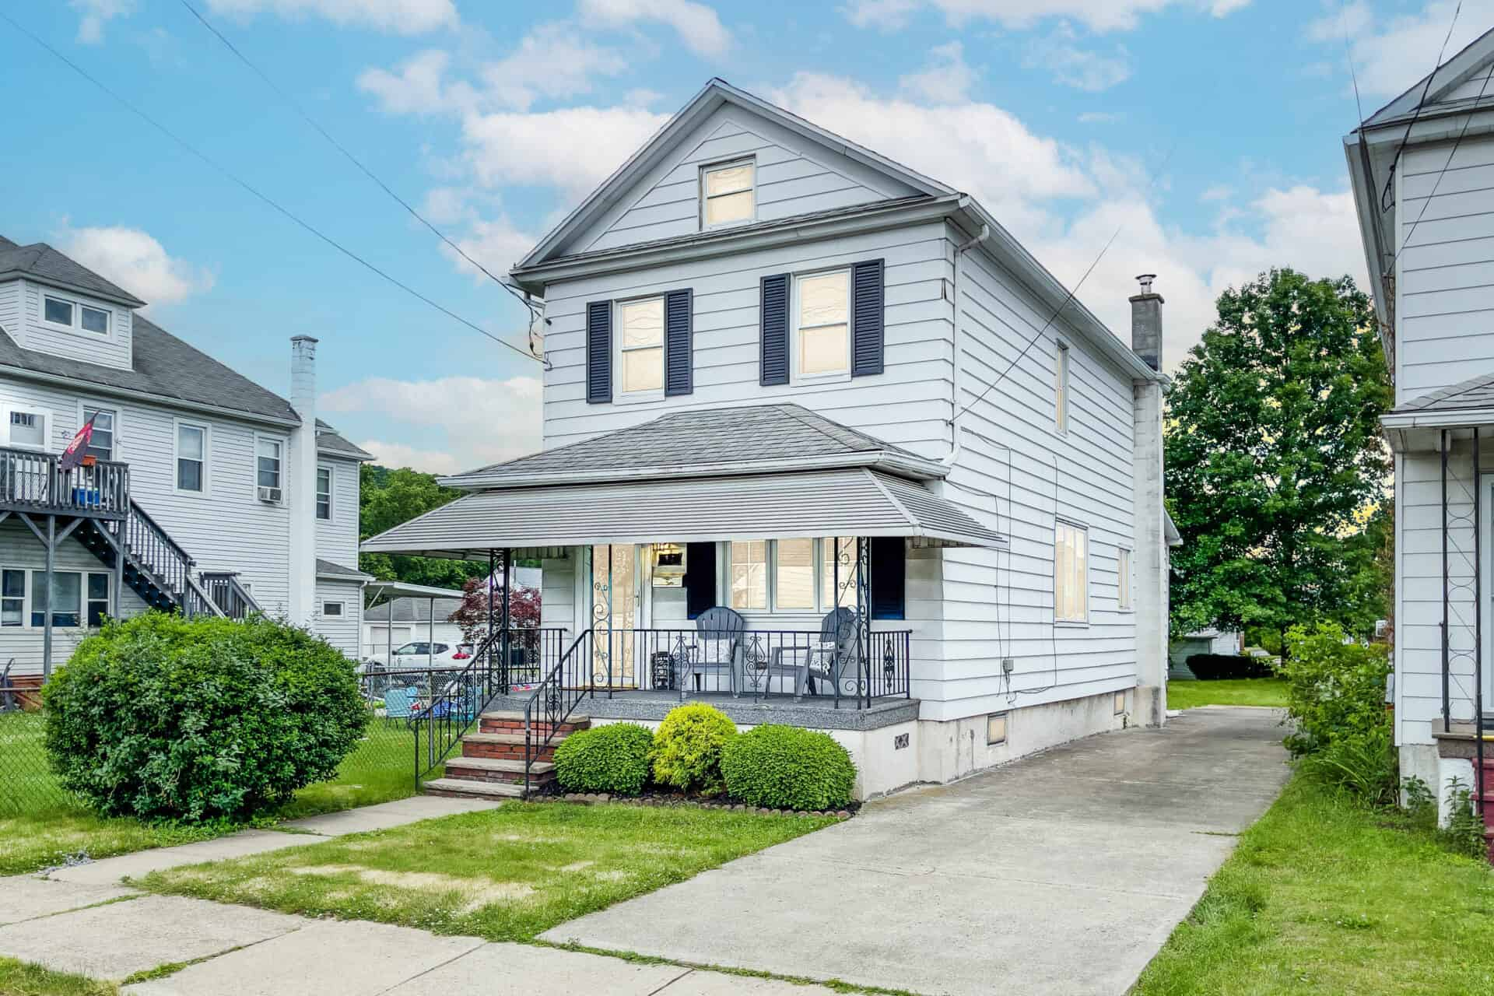

- Image URL is https://www.pikelandpropertygroup.com/wp-content/uploads/2024/06/sell-my-house-fasts-pennsylvania-scaled.jpg
- Image filename is sell-my-house-fasts-pennsylvania-scaled.jpg
- File size is 194kb
- Alt text is missing

RECOMMENDATIONS
- Add descriptive alt text to the surveyed image.
  - Suggested alt text: Pennsylvania house sold fast for cash with Pikeland Property Group
- Fix the filename when the image is next replaced or re-uploaded.
  - Current filename: sell-my-house-fasts-pennsylvania-scaled.jpg Suggested filename: sell-my-house-fast-pennsylvania.jpg
- Keep the image relevant to the homepage keyword focus.
  - The image supports the homepage’s commercial focus around sell my house fast, sell my house for cash, and we buy houses Pennsylvania, so the alt text should describe the property image while reinforcing that fast cash sale context naturally.
- Review compression.
  - The file size is 194kb, which is not excessive, but it could still be compressed further if image quality can be preserved.
    - Consider using the .avif file type and compressing the image while maintaining quality.

PHOENIXVILLE PAGE FINDINGS: https://www.pikelandpropertygroup.com/sell-your-house-fast-in-phoenixville-pa/
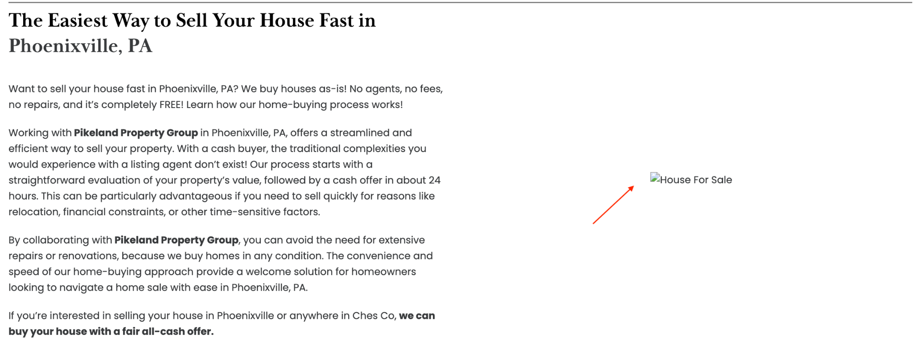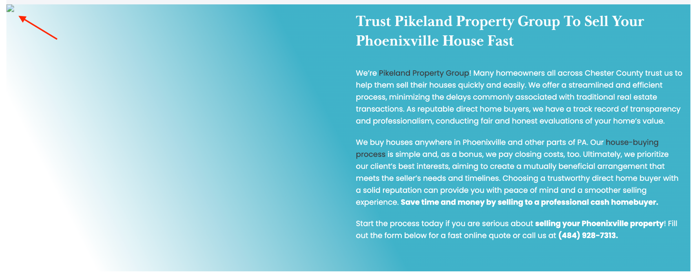

- n/a
- n/a
- Images are not displaying on the page
  - Error messages: Image 1, Image 2

RECOMMENDATIONS
- Confirm the affected image URLs return a valid 200 status.
  - Replace any missing, blocked, or incorrectly referenced image files with working image URLs.
- Use a locally relevant image where possible.
- If the broken images are being replaced, use an image that supports the Phoenixville cash buyer page rather than a generic stock or template image.
- Add descriptive alt text after the image is fixed.
  - Suggested alt text: Phoenixville PA house that can be sold fast for cash
  - The image should support the page’s H1, We Buy Houses In Phoenixville, PA For Cash, and the recommended title/meta updates for selling a house fast in Phoenixville.

BLOG POST FINDINGS: https://www.pikelandpropertygroup.com/wp-content/uploads/2024/06/need-to-sell-my-house-fast.jpg


- File size is 142kb
- Image URL is https://www.pikelandpropertygroup.com/wp-content/uploads/2024/06/need-to-sell-my-house-fast.jpg
- Image filename is need-to-sell-my-house-fast.jpg
- Alt text is missing

RECOMMENDATIONS
- Add descriptive alt text to the surveyed image.
  - Suggested alt text: neighbourhood homes in Pennsylvania for homeowners selling to a direct buyer
- Improve the filename when the image is next replaced or re-uploaded.
  - Current filename: need-to-sell-my-house-fast.jpg Suggested filename: selling-home-to-direct-buyer-pennsylvania.jpg
- Match the image to the article topic.
  - The current filename supports broad “sell my house fast” intent, but this article is specifically about selling to a direct buyer in Pennsylvania, so the filename and alt text should reflect that topic more closely.
- Use the image as part of the wider blog overhaul.
  - This image optimisation should happen alongside the title, meta description, H1, and content improvements already recommended for the direct buyer blog content.


lLINKS & SILOINGl

Links & Siloing
In this section we will look at site structure both in terms of physical siloing as well as virtual siloing and anchor text. These attributes will be analysed in terms of how they improve Google’s understanding of your site and user experience.

Physical Siloing & URL Structure

Siloing is a form of site architecture where hierarchical groupings are created that are determined by topics and subtopics.

Physical siloing is when theme-related pages to be located within the same directory of a site, such as:
- In the URL https://www.example.com/blog/title “/blog/” is a physical silo. It allows users to understand that the URL is a blog post. It allows Google to understand the intent of the page better.
- Likewise, in https://www.example.com/services/seo “/services/” is a physical silo.
- In the case of https://www.example.com/services/seo/audit “/services/” and “/seo/” would be physical silos.

Besides physical siloing there are several other factors relating to URLs which can affect your position on Google:
- The URL being short (measured in number of characters)
- The presence of keywords in the URL
  - Typically you want your main keyword in the URL.
  - The keyword should appear in the first few words of the URL.
  - Avoid having too many keywords (as this will make the URL longer and Google doesn’t like “keyword stuffing”).

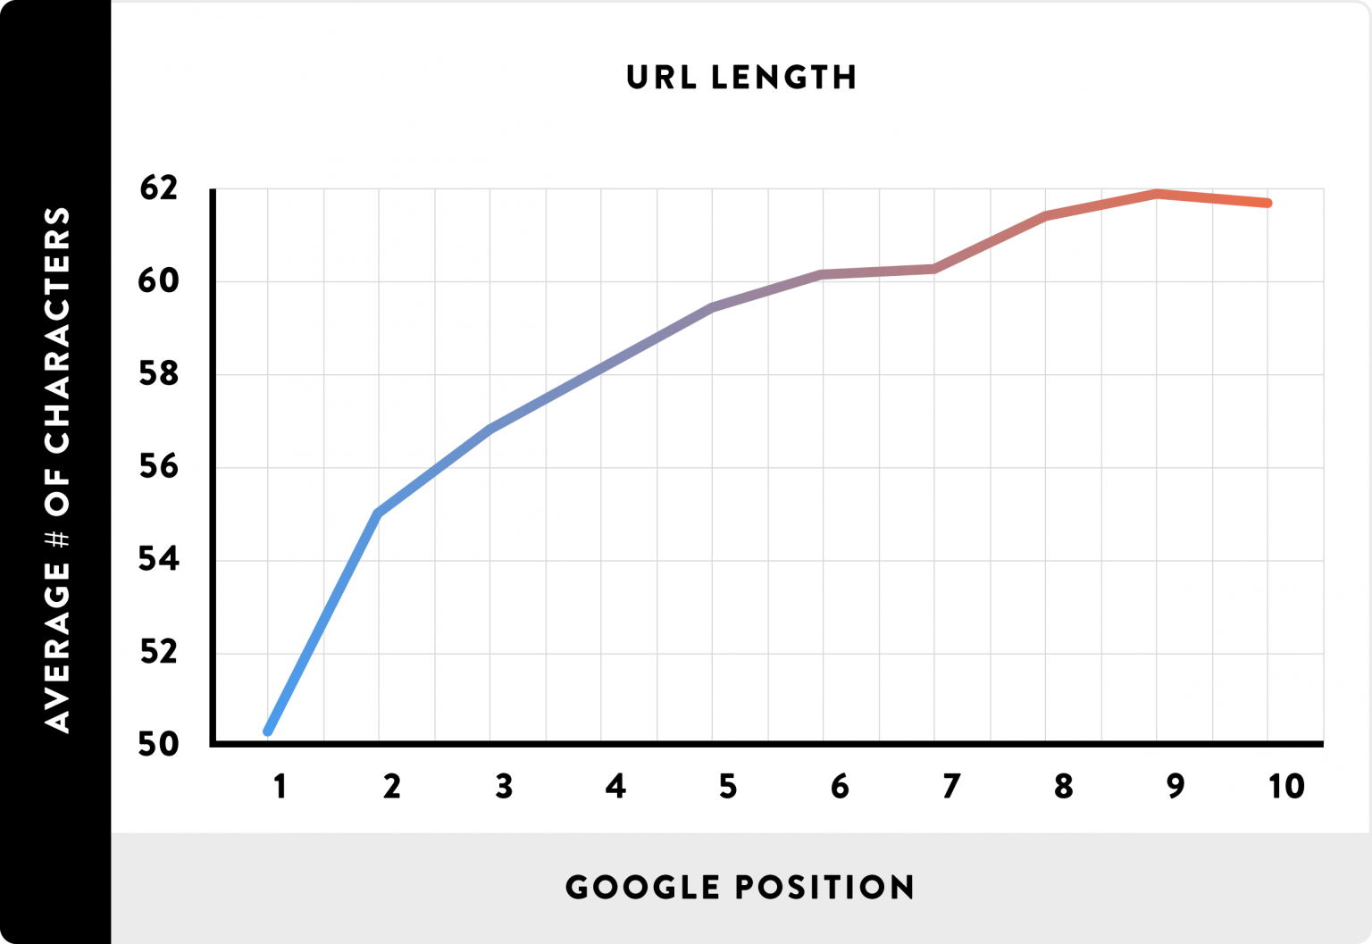

These additional factors should be taken into account when creating physical siloing, going back to our previous example:
- In the URL https://www.example.com/services/seo/seo-audit the second use of “seo” is unnecessary because:
  - “seo” already appears in the URL and this would count as keyword stuffing.
  - It makes the URL longer.
  - It moves the main keyword “seo audit” further away from the start of the URL.
- However, in the URL https://www.example.com/services/seo/content-audit the use of “content” adds value (from an SEO perspective).

DATA COLLECTION

 | Long URLs
 | Stop words

FINDINGS

- All key URLs reviewed return a 200 status code and are indexable.
  - This means the pages included in the audit data are accessible to search engines.
  - There are no 404, 500, or redirecting URLs in the indexable 200 URL set reviewed.
- The site uses a consistent trailing slash format across the indexable URLs reviewed.
- Core commercial URLs are short and easy to understand. Examples include:
  - https://www.pikelandpropertygroup.com/
  - https://www.pikelandpropertygroup.com/get-your-offer/
  - https://www.pikelandpropertygroup.com/how-we-buy-houses/
  - https://www.pikelandpropertygroup.com/contact-us/
- Several URLs are very long, especially across blog and FAQ content. Examples include:
  - https://www.pikelandpropertygroup.com/blog/pennsylvania-real-estate-investors-can-incorporate-multi-family-properties-into-their-portfolios/
  - https://www.pikelandpropertygroup.com/blog/faq-items/will-you-list-my-house-on-the-mls-or-will-you-be-the-actual-buyer/
  - https://www.pikelandpropertygroup.com/blog/costs-you-may-face-when-selling-your-house-pennsylvania/
  - https://www.pikelandpropertygroup.com/blog/selling-a-property-that-needs-repairs-in-pennsylvania/
- These URLs are not technically broken, but they are longer than necessary and read like full article titles rather than clean SEO slugs.
- This is especially relevant for the costs and repairs articles, as these were already identified in the keyword research section as pages that should be overhauled.
- The location page URL structure is keyword-relevant, but the physical siloing is shallow. Examples include:
  - https://www.pikelandpropertygroup.com/sell-your-house-fast-in-philadelphia-pa/
  - https://www.pikelandpropertygroup.com/sell-your-house-fast-in-reading-pa/
  - https://www.pikelandpropertygroup.com/sell-your-house-fast-in-wilmington-de/
  - https://www.pikelandpropertygroup.com/sell-your-house-fast-in-york-pa/
    - The URL slugs are clear and include local search intent, which is positive.
    - However, the location pages sit at the root level rather than inside a dedicated location folder.
    - This means the URL structure does not physically group location pages together in a clear location silo.
    - This is not necessarily a reason to change the current URLs, but it should be considered when creating new location pages or planning a future site restructure.
- N/A

GENERAL RECOMMENDATIONS
- Keep the existing top-level commercial URLs where they are already clean and easy to understand. This includes:
  - https://www.pikelandpropertygroup.com/get-your-offer/
  - https://www.pikelandpropertygroup.com/how-we-buy-houses/
  - https://www.pikelandpropertygroup.com/compare/
  - https://www.pikelandpropertygroup.com/avoiding-foreclosure/
    - Do not change these URLs unless there is a wider migration or restructuring project.
- Keep the current location URL format for existing location pages.
  - The current format is keyword-relevant and easy to understand. Example:
  - https://www.pikelandpropertygroup.com/sell-your-house-fast-in-philadelphia-pa/
  - Avoid moving existing location URLs into a new folder unless there is a full URL migration plan with 301 redirects.
  - For future location pages, use one consistent URL convention.
    - The lowest-risk option is to continue the existing format:
    - https://www.pikelandpropertygroup.com/sell-your-house-fast-in-[city]-[state]/
    - If the site is restructured in future, a cleaner physical location silo could be considered. Example:
    - https://www.pikelandpropertygroup.com/locations/philadelphia-pa/
    - However, this should only be done as part of a planned migration.
- Avoid creating more long FAQ-item URLs for commercially important topics.
- Where a FAQ topic supports a major service or seller situation, place it within the relevant main page or guide instead.
  - For example, questions about as-is selling, repairs, fees, commissions, and cash offers should support the main service/situation pages rather than sitting as isolated long FAQ URLs.
- When overhauling existing blog articles, shorten URLs only if the page is being substantially improved and a 301 redirect can be implemented.

PAGE URL: https://www.pikelandpropertygroup.com/blog/pennsylvania-real-estate-investors-can-incorporate-multi-family-properties-into-their-portfolios/

RECOMMENDATIONS
- Consider cleaning up the URL if this article is kept and overhauled.
  - The current URL is very long and reads like the full article title.
  - If the article is not a priority, avoid changing the URL only for cosmetic reasons.
  - If the article is rewritten, use a shorter URL focused on the main topic. Example:
    - https://www.pikelandpropertygroup.com/blog/multi-family-real-estate-investors-pennsylvania/

PAGE URL: https://www.pikelandpropertygroup.com/blog/faq-items/will-you-list-my-house-on-the-mls-or-will-you-be-the-actual-buyer/

RECOMMENDATIONS
- Consider consolidating this FAQ into a stronger comparison or cash buyer page.
  - The current URL is long and sits within the /blog/faq-items/ path, even though the topic is commercially important.
  - This question would be better placed within content explaining how Pikeland buys houses directly compared with listing through an agent.
  - If kept as a standalone page, shorten the URL. Example:
    - https://www.pikelandpropertygroup.com/blog/faq-items/will-you-list-my-house/

PAGE URL: https://www.pikelandpropertygroup.com/blog/costs-you-may-face-when-selling-your-house-pennsylvania/

RECOMMENDATIONS
- Shorten the URL if this article is overhauled as recommended in the keyword research section.
  - The current URL is relevant but longer than necessary.
  - A cleaner URL would better support the keyword opportunity around cost and fees when selling a house. Recommended URL example:
    - https://www.pikelandpropertygroup.com/blog/cost-of-selling-a-house-pennsylvania/
  - This better aligns with cost of selling a house, which has 900 search volume and KD 6.

PAGE URL: https://www.pikelandpropertygroup.com/blog/selling-a-property-that-needs-repairs-in-pennsylvania/

RECOMMENDATIONS
- Shorten the URL if this article is overhauled around as-is selling and repairs.
  - The current URL is relevant but does not reflect the strongest keyword opportunity as clearly as it could. Recommended URL example:
    - https://www.pikelandpropertygroup.com/blog/sell-house-needs-repairs-pennsylvania/
  - This better supports the keyword opportunities around sell house as is, sell house as is for cash, and selling a property that needs repairs.

Virtual Siloing & Linking

A large part of how Google ranks pages is their authority, and this usually boils down to how many links are pointing to that page. When a link points to a page it will usually pass on authority (sometimes referred to as ‘link juice’).

Internal links direct users from pages on your site to other pages on your site, e.g. from your homepage to your contact page. These links can help spread authority to the important pages on your website.

Internal links can be used to create virtual siloing. Virtual siloing occurs when pages about a certain topic link to one another and/or to a central page on the topic, for example:

- The blog post https://www.example.com/blog/seo-audits-find-problems and other similar SEO posts link to the service page https://www.example.com/services/seo/audit

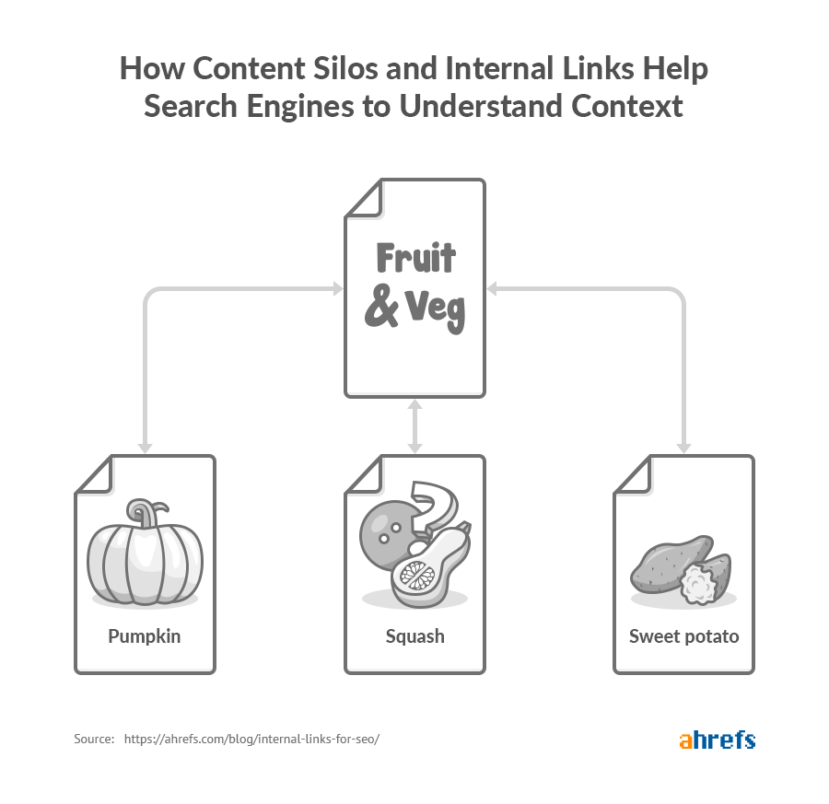

There are three main benefits of virtual siloing:

- Users will have an easier time navigating around your site.
- Crawlers will have an easier time understanding your site structure and content.
- More “authority” is transferred to your most important pages.

External links (aka outbound links) direct users from pages on your website to other sites on the internet, e.g. from your homepage to your Facebook profile. These links can pass authority from your site onto another site.

External links can provide relavency to search engines so that they better understand the intention of the page (e.g. if you have a page about apples and you link to the Wikipedia page about the fruit, then this will help Google to understand that you are not talking about the technology company).

External links are not to be confused with backlinks - backlinks are links from other sites to your site. Backlinks can pass authority on to your site.

Links can also have attributes such as:

- follow (which indicates to the search engine that authority should be passed on to the linked page)
- nofollow (which indicates that authority should not be passed on to the linked page)

You should use nofollow links when you are linking to pages you don’t have full confidence in or in your comments section (if you have one). In other cases just use follow links.

DATA COLLECTION

 | Internal linking
 | External linking
 | Orphan pages

FINDINGS

- All key indexable pages have at least some internal links pointing to them.
  - This means the main crawlable pages are not completely isolated.
  - The Results, Sign Up, Recover PIN, Terms, homepage, mobile entry, and contact pages are all discoverable through internal links.
- Internal linking is heavily weighted toward navigation, footer, category, archive, and utility links rather than contextual links within page content.
  - This means the site is not doing enough to show relationships between its key commercial pages, location pages, and supporting blog content.
  - Many blog posts only receive 3 to 4 internal inlinks.
  - This limits how effectively the blog can support commercial pages such as location pages, cash offer pages, comparison content, and seller-situation pages.
- The location page silo is weak from an internal linking perspective.
  - Several important location pages are indexable HTTP 200 pages but have 0 internal inlinks in the crawl. Examples include:
    - https://www.pikelandpropertygroup.com/sell-your-house-fast-in-philadelphia-pa/
    - https://www.pikelandpropertygroup.com/sell-your-house-fast-in-reading-pa/
    - https://www.pikelandpropertygroup.com/sell-your-house-fast-in-wilmington-de/
    - https://www.pikelandpropertygroup.com/sell-your-house-fast-in-york-pa/
    - https://www.pikelandpropertygroup.com/sell-your-house-fast-in-lancaster-pa/
    - https://www.pikelandpropertygroup.com/sell-your-house-fast-in-phoenixville-pa/
    - https://www.pikelandpropertygroup.com/sell-your-house-fast-in-pittsburgh-pa/
  - This is important because the keyword research and ranking data show local search opportunities around these pages.
- The service and seller-situation silo is also underdeveloped.
  - Pages about selling as-is, repair issues, fees, commissions, foreclosure, cash offers, and direct buyer comparisons should support one another more clearly through contextual internal links.
  - Relevant pages include:
    - https://www.pikelandpropertygroup.com/get-your-offer/
    - https://www.pikelandpropertygroup.com/get-a-cash-offer-today/
    - https://www.pikelandpropertygroup.com/compare/
    - https://www.pikelandpropertygroup.com/avoiding-foreclosure/
    - https://www.pikelandpropertygroup.com/blog/costs-you-may-face-when-selling-your-house-pennsylvania/
    - https://www.pikelandpropertygroup.com/blog/selling-a-property-that-needs-repairs-in-pennsylvania/
  - The costs and repairs articles were already identified in the keyword research section as pages that should be overhauled, so they should also be used to strengthen the internal linking between informational and commercial pages.
- External links are mainly made up of social-share and utility links rather than editorial citations.
  - The external link data shows high counts for ClickCease and social-sharing domains such as Pinterest, Reddit, LinkedIn, X, Facebook, Tumblr, Xing, and WhatsApp.
  - There are a small number of more useful reference domains, such as Investopedia, NerdWallet, FDIC, and IRS.
  - This is not necessarily a major issue, but it means external linking is not currently adding much trust or supporting evidence to important advice-led content.
- Some external links appear to point to old staging or template-style domains.
  - Examples include:
    - https://natebeekseller2.carrot.com/
    - https://wordpress-518161-3660298.cloudwaysapps.com/
    - https://wordpress-696865-2861175.cloudwaysapps.com/
  - These should be reviewed to confirm whether they are visible links on the site.
- Several high-value indexable pages have 0 internal inlinks. This includes key location pages and commercial support pages.
  - Examples include:
    - https://www.pikelandpropertygroup.com/sell-your-house-fast-in-philadelphia-pa/
    - https://www.pikelandpropertygroup.com/sell-your-house-fast-in-reading-pa/
    - https://www.pikelandpropertygroup.com/sell-your-house-fast-in-wilmington-de/
    - https://www.pikelandpropertygroup.com/sell-your-house-fast-in-pittsburgh-pa/
    - https://www.pikelandpropertygroup.com/sell-your-house-fast-in-york-pa/
    - https://www.pikelandpropertygroup.com/sell-your-house-fast-in-lancaster-pa/
    - https://www.pikelandpropertygroup.com/compare/
    - https://www.pikelandpropertygroup.com/avoiding-foreclosure/
  - This weakens the site’s ability to signal which commercial and local pages are most important.

RECOMMENDATIONS
- Strengthen the internal linking to priority location pages.
  - The homepage, how-we-buy-houses page, get-your-offer page, FAQ page, and relevant seller blog posts should link contextually to the most important location pages.
  - Priority location pages include:
    - https://www.pikelandpropertygroup.com/sell-your-house-fast-in-philadelphia-pa/
    - https://www.pikelandpropertygroup.com/sell-your-house-fast-in-reading-pa/
    - https://www.pikelandpropertygroup.com/sell-your-house-fast-in-wilmington-de/
    - https://www.pikelandpropertygroup.com/sell-your-house-fast-in-york-pa/
    - https://www.pikelandpropertygroup.com/sell-your-house-fast-in-lancaster-pa/
    - https://www.pikelandpropertygroup.com/sell-your-house-fast-in-pittsburgh-pa/
  - This will help reinforce the local “sell my house fast” and “we buy houses” opportunities identified in the keyword research.
- Build a clearer location silo through contextual links.
  - Relevant Pennsylvania pages should link to Pennsylvania location pages.
  - Relevant Delaware pages should link to Delaware location pages.
  - Location pages should also link back to the main offer and process pages where useful.
    - This will help users and search engines understand which areas Pikeland serves.
    - Strengthen the service and seller-situation silo.
  - The costs article should link to the comparison page, get-your-offer page, and repairs/as-is content.
  - The repairs article should link to the get-your-offer page, comparison page, and relevant location pages.
  - The foreclosure page should link to the cash offer and process pages.
  - The comparison page should link to the costs article, direct buyer content, and get-your-offer page.
  - This will connect informational content to the commercial pages that are most likely to convert.
- Prioritise internal links to pages that currently have 0 internal inlinks before adding more links to pages that already receive sitewide navigation support.
  - This includes the location pages, comparison page, and foreclosure page.
  - Add links within body copy rather than relying only on menus, footers, category links, archive links, or pagination links.
- Review external links to staging or template-style domains.
  - Remove or replace these links if they are visible to users.
  - Where advice-led pages make claims about costs, taxes, foreclosure, financing, or legal/financial processes, use relevant authoritative external sources where appropriate.
    - This is especially useful for the costs article, foreclosure page, and any future informational guides.

Anchor Text
Anchor text is the clickable text in a hyperlink (i.e. the text which is underlined and blue). Anchor text should ideally be succinct, unique (not generic), not overly keyword heavy (don’t stuff too many keywords), and relevant to the target page (the page being linked to).
There are different types of anchor text, such as:

- Exact-match (the main keyword of the page being linked to),
- Partial-match (a variation of the main keyword),
- Branded (the brand name of the website being linked to),
- Naked link (just the URL in plain text),
- Generic (generic text (e.g. “click here”, “download”, etc.)),
- Image (i.e. an image which is a link).

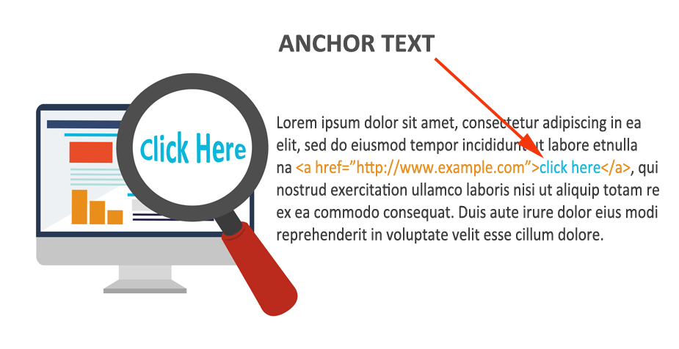
So an example (for the link https://woww.co.za/wordpress-seo-services/) of bad anchor text is “Click HERE!” and a good anchor text is “Woww SEO services” (branded partial-match anchor text relevant to the link). Some of your anchors will be generic due to their nature (e.g. menu headers, “contact us”, etc.) and this isn’t a problem.

Anchor text shouldn’t be longer than about 60 characters (unless it’s a naked URL).

Anchor text isn’t only applicable to the links on your website. Anchor text is also applicable to other websites’ links to your site (backlinks). You want the majority of your backlinks to your site to be branded anchors (~70%) and then naked link anchors (~20%).

The remaining 10% of anchors can be generic, partial-match, and exact-match. What you want to avoid is ‘over-optimisation’ - i.e. too many exact-match (or partial-match) backlinks (because Google would view this as spam - as you trying to cheat the system).

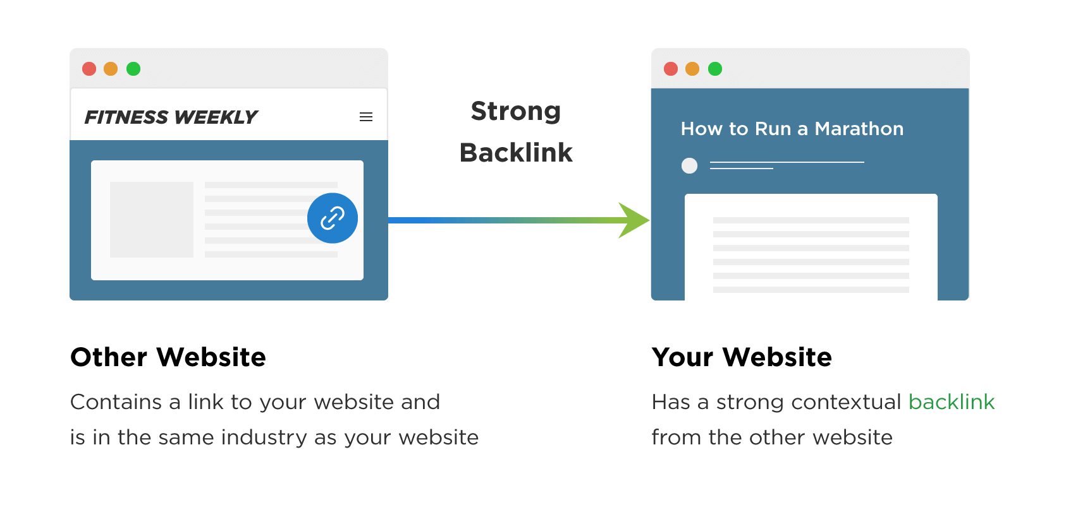
DATA COLLECTION

 | Anchor Text

FINDINGS

- Some internal anchor text is clear and action-led.
  - Examples include:
    - Get Your Free Offer
    - Get My Free Offer
    - Yes! I want to get my fair cash offer!
    - How It Works
      - These anchors are useful for users because they clearly describe the action or destination.
- The internal anchor text profile is heavily shaped by navigation, footer, category, archive, author, and pagination links.
  - Examples include:
    - Reviews
    - Privacy Policy
    - Contact
    - Pikeland Property Group Logo
    - About Us
    - sellers
    - building-credibility
    - buying-mobile-homes
    - selling-mobile-homes
    - Uncategorized
    - Tommy
    - Next
    - Previous
    - September 2023
      - These anchors are not necessarily wrong, but they do not strongly reinforce the site’s main SEO themes.
- The blog is technically interlinked, but much of the blog-to-blog anchor text is driven by categories, archives, pagination, author links, and full article titles rather than contextual in-copy links.
  - The crawl shows article-title anchors such as:
    - Commissions, Repairs, Marketing, and Other Potential Costs You May Face When Selling Your House in Pennsylvania
    - 6 Things You Need to Know About Selling a Property That Needs Repairs in Pennsylvania
  - These are technically descriptive, but they are long and title-led rather than concise contextual anchors.
- The blog links to some commercial pages, but the anchor text is mostly broad call-to-action or navigation-led.
  - Examples include:
    - Get My Free Offer
    - Get Your Free Offer
    - How It Works
    - Go here to learn about our process →
  - These links are useful for conversion, but they do not fully support keyword themes such as selling as-is, selling for cash, fees, commissions, repairs, foreclosure, and direct buyer comparisons.
- The blog does not appear to meaningfully link to the priority city location pages using local anchor text.
  - The crawl did not find contextual blog links pointing to key city pages such as:
    - https://www.pikelandpropertygroup.com/sell-your-house-fast-in-philadelphia-pa/
    - https://www.pikelandpropertygroup.com/sell-your-house-fast-in-reading-pa/
    - https://www.pikelandpropertygroup.com/sell-your-house-fast-in-wilmington-de/
    - https://www.pikelandpropertygroup.com/sell-your-house-fast-in-york-pa/
    - The only blog-to-location-style links found point to the FAQ-style Pennsylvania page:
    - https://www.pikelandpropertygroup.com/blog/faq-items/sell-your-house-fast-in-pennsylvania/
  - The anchor text used for these links includes:
    - Next
    - Previous
    - Sell Your House Fast in Pennsylvania
  - This means the blog is not currently passing strong local contextual signals to the city pages that need to rank for local “sell my house fast” and “we buy houses” queries.

RECOMMENDATIONS
- Replace generic anchor text with descriptive anchor text where possible.
  - This is most important for links placed within body copy.
  - Navigation anchors such as Contact, Reviews, and About Us can remain simple, but contextual links should describe the page being linked to.
- Use location-focused anchor text when linking to location pages.
  - For the Philadelphia page, use anchors such as:
    - sell your house fast in Philadelphia
    - cash home buyers in Philadelphia
    - sell a house as-is in Philadelphia
    - For the Reading page, use anchors such as:
    - sell your house fast in Reading PA
    - cash home buyers in Reading
    - sell your Reading house as-is
    - For the Wilmington page, use anchors such as:
    - sell your house fast in Wilmington DE
    - cash home buyers in Wilmington
    - sell a house for cash in Wilmington
  - For the York page, use anchors such as:
    - We buy houses in York PA
    - sell your house fast in York PA
    - sell a house as-is in York
- When overhauling blog articles, add contextual links from relevant blog posts to priority location pages.
  - For example, the repairs/as-is article should link to relevant city pages using anchor text such as:
    - sell a house as-is in Philadelphia
    - sell your house fast in Reading PA
    - cash home buyers in Wilmington DE
    - we buy houses in York PA
  - The costs article should link to location pages where the content discusses local selling costs, commissions, or cash sale alternatives.
    - Use anchor text such as:
    - costs of selling a house in Philadelphia
    - sell your house without commissions in Reading PA
    - cash home buyers in Wilmington DE
  - Use service and seller-situation anchor text to support the main commercial pages.
    - For the comparison page, use anchors such as:
    - compare selling to a cash buyer vs an agent
    - cash buyer vs listing with an agent
    - avoid commissions and repair costs
  - For the foreclosure page, use anchors such as:
    - avoid foreclosure in Pennsylvania
    - sell before foreclosure
    - cash offer before foreclosure
  - For the get-your-offer page, use anchors such as:
    - get a cash offer
    - request a fair cash offer
    - sell your house for cash
      - Use keyword-informed anchor text when overhauling the existing blog content.
  - For the costs article, use anchors such as:
    - cost of selling a house in Pennsylvania
    - fees when selling a house
    - selling costs and commissions
    - For the repairs article, use anchors such as:
    - sell a house as-is
    - sell a house that needs repairs
    - cash offer for a house needing repairs
  - Avoid relying on Next, Previous, author names, month archives, category labels, and logo anchors as the main blog anchor text.
    - These links are fine for navigation, but they should be supported by in-copy links that connect blog articles to the location and service pages they are meant to support.
- Use partial-match anchor text rather than repeating the same exact keyword every time.
  - This will help the anchor text profile look natural while still reinforcing the site’s main location, cash buyer, as-is selling, cost, foreclosure, and comparison topics.

On Page Content

lON PAGEl lCONTENTl
The content (or “copy”) of a page is very important. Weak content with strong optimization won’t perform. Strong content without effective optimization also won’t perform. You need both strong content and effective optimization to drive search engine traffic.

“Content” can refer to blog posts and guides, but it can also refer to any on page text, notably such as product descriptions and service descriptions. It’s not uncommon to see websites which are willing to write somewhat lengthy blog posts but fail to write adequately long product or service descriptions.

Correlation Analysis
In this subsection we use a correlational SEO service to analyse 3 pages on your site. This allows us to analyse the keyword usage on the page from a more analytical perspective. This is also useful because it gives an overview of each page as the sum of its components, rather than looking at each of the components individually (as has been done above). The recommendations should be taken with a grain of salt.

- Home page: https://www.pikelandpropertygroup.com/
- Get your offer: https://www.pikelandpropertygroup.com/get-your-offer/
- Phoenixville (location page): https://www.pikelandpropertygroup.com/sell-your-house-fast-in-phoenixville-pa/
- Blog post: https://www.pikelandpropertygroup.com/blog/selling-your-home-to-a-direct-buyer-in-pennsylvania-3/

DATA COLLECTION

 | Home page (Target keyword: sell my house fast pennsylvania)
 | Get your offer (Target keyword: get cash offer for house)
 | Location page - Phoenixville (Target keyword: we buy houses phoenixville pa)
 | Blog post (Target keyword: direct home buyers pennsylvania)  - (Alternative target keyword: advantages of selling your home to a direct buyer in pennsylvania)

FINDINGS

- The homepage, Get Your Offer page, and Phoenixville page all have one H1, and Surfer did not flag internal linking as an issue for the homepage or Get Your Offer page. The homepage also has strong technical performance, with TTFB at 376ms and load time at 2,347ms.
- The Phoenixville page is the strongest audited page from a content-correlation perspective, with a Content Score of 64 and only a 4-point improvement gap. Page speed is also within Surfer’s optimal range.
- The homepage has a Content Score of 52 and needs a 16-point improvement. Surfer shows 314 of 429 important terms require attention, and the exact target keyword is missing from the title, H1, and body. The page is also too long overall, with 6,108 body words against a suggested range of 2,287-3,290, while heading coverage is still too light.
- The Get Your Offer page also has a technical performance issue. Surfer reports TTFB at 1,521ms, which is 401ms above the recommended maximum, although full load time is still within range.
- The Phoenixville page is close to competitive, but still misses the exact target keyword from the title, H1, and body. It also needs stronger supporting content, more H2-H6 coverage, and internal links from 5 relevant pages.
- The Get Your Offer page is the weakest commercial page in the audit, with a Content Score of 19 and a 49-point improvement gap. It is missing the exact target keyword from the title, H1, and body, has only 2 H2-H6 headings, and has 257 of 308 important terms requiring attention.
- The blog post targeting direct home buyers has a Content Score of 37 and needs a 31-point improvement. It is significantly underdeveloped compared with competitors, with 852 body words against a suggested range of 3,348-7,610, only 9 H2-H6 elements against a suggested 30-55, and only 2 images against a suggested 9-16.
- The blog post also has technical and metadata issues. Surfer reports TTFB at 1,478ms and load time at 3,646ms, both above the recommended range. The title is also too long at 123 characters, and the meta description is too long at 233 characters.

RECOMMENDATIONS
- Prioritise the Get Your Offer page first.
  - Rework the page around “get cash offer for house” by adding the exact keyword to the title, H1, intro, and body copy, then expand the page with clear sections covering how the cash offer works, no-obligation offers, all-cash offers, closing timelines, fewer contingencies, closing costs, and selling as-is.
- Optimise the homepage around “sell my house fast Pennsylvania”, but do not simply add more copy.
  - Surfer indicates the page is already too long, so the work should focus on pruning duplicated or low-value copy, adding the exact keyword to the title/H1/body, tightening the meta description, and improving heading structure around cash offers, Pennsylvania homeowners, closing costs, as-is sales, and cash home buyers.
- Make lighter but important edits to the Phoenixville page.
  - Add “we buy houses Phoenixville PA” to the title, H1, and body, shorten the title, rewrite the meta description to 130-150 characters, add more local supporting sections, and add internal links from the homepage, Our Company, Get Your Offer, author page, and Reviews page.
- Treat the direct-buyer blog post as a major content expansion or consolidation task.
  - Add the exact keyword to the title, H1, intro, and body, then expand the article with sections on direct home buyers in Pennsylvania, cash home buyers, fair cash offers, closing costs, selling as-is, realtor fees, repair costs, inherited properties, and when a direct cash sale makes sense.
- Add the missing internal links to the Phoenixville page and blog post using natural anchors.
  - The Phoenixville page has 5 internal link opportunities, and the blog post has 6, so this is a quick win alongside the content updates.
- After edits are complete, rerun the Surfer audits and prioritise Content Score movement on Get Your Offer and the blog first, then homepage, then Phoenixville.

Content Length
It is important to have long content. The length will depend on the content type, for example:
- A product description might be 50-150 words
- A service description might be 300-500 words (or more)
- An evergreen piece of content might be 750-1000 words
- An in-depth guide might be 3000-4000 words (or more)

These are more guidelines than strict rules and the suggestions will vary depending on the context, but generally more is better. Blog posts should generally be 1000 words at least - anything lower is likely going to be too threadbare.

DATA COLLECTION

 | Content length

FINDINGS

- Some priority pages have enough main content once the live pages are reviewed manually.
  - Examples include:
    - https://www.pikelandpropertygroup.com/how-we-buy-houses/
Approximate main-content word count: 1,160 words.
    - https://www.pikelandpropertygroup.com/sell-your-house-fast-in-philadelphia-pa/
Approximate main-content word count: 1,789 words.
    - https://www.pikelandpropertygroup.com/sell-your-house-fast-in-reading-pa/
Approximate main-content word count: 1,691 words.
    - These pages are not thin from a content-length perspective.
    - However, the location pages still need stronger local uniqueness, better page alignment, and stronger internal linking support.
- Several important blog articles are lighter than the raw crawl figures suggest once template content is removed.
  - Examples include:
    - https://www.pikelandpropertygroup.com/blog/costs-you-may-face-when-selling-your-house-pennsylvania/
Approximate main-content word count: 710 words.
    - https://www.pikelandpropertygroup.com/blog/selling-a-property-that-needs-repairs-in-pennsylvania/
Approximate main-content word count: 690 words.
- These articles are not empty, but they are likely too shallow for the keyword opportunities identified earlier in the audit.
- The costs article should better support topics such as selling costs, agent commissions, closing costs, repair costs, holding costs, and cash sale comparisons.
- The repairs article should better support topics such as selling as-is, no repairs, inspections, repair deductions, and cash buyer expectations.
- The comparison page has useful commercial intent, but it is still relatively light.
  - https://www.pikelandpropertygroup.com/compare/. Approximate main-content word count: 650 words.
  - The page includes a useful comparison table, but it would benefit from more supporting explanation around the financial and practical differences between selling to Pikeland and listing with an agent.
- The avoiding foreclosure page is too light for a high-intent seller-situation page.
  - https://www.pikelandpropertygroup.com/avoiding-foreclosure/
  - Approximate main-content word count: 230 words.
  - This is not enough useful content for a page dealing with foreclosure, urgency, financial pressure, and homeowner decision-making.
  - The page should provide clearer guidance, more context, and stronger trust signals.
- Some standalone FAQ pages are too thin to justify being relied on as indexable search pages.
  - Example:
  - https://www.pikelandpropertygroup.com/blog/faq-items/what-does-as-is-mean/
  - Approximate main-content word count: 140 words.
  - The topic is useful, but the page is too short as a standalone search result.
  - This type of content would work better as part of a stronger repairs/as-is guide or FAQ section on a relevant commercial page.

RECOMMENDATIONS
- Do not add content purely to increase word count.
  - Content should only be added where it improves search intent match, user understanding, trust, conversion, or topical depth.
- Keep the how-we-buy-houses page as a stronger content-depth example, but refine the copy where needed.
  - The page has enough main content to explain the process, but it should continue to support the core cash offer journey with clear internal links to relevant service, FAQ, and location pages.
- Treat the location pages as “enough content, but needs better uniqueness” and publishing to ensure quality.
  - Priority examples include:
  - https://www.pikelandpropertygroup.com/sell-your-house-fast-in-philadelphia-pa/
  - https://www.pikelandpropertygroup.com/sell-your-house-fast-in-reading-pa/
  - They can be improved with more genuinely local copy, local trust signals, local property/seller examples, and better links to relevant seller-situation content.
  - Correcting the placeholder content in the meta title, creating an appropriate length meta description, pointing internal links to the location pages from relevant content, creating internal links to blog posts/FAQ content, setting keyword-rich and descriptive alt text, may also help.
- Overhaul the costs article.
  - The article should be expanded into a more complete guide covering:
    - Agent commissions
    - Closing costs
    - Repair costs
    - Holding costs
    - Staging and marketing costs
    - Cash sale comparison
    - Pennsylvania-specific seller considerations
    - FAQs around fees and commissions
  - This supports the keyword opportunities around cost of selling a house and fees for selling a house.
- Overhaul the repairs article.
  - The article should be expanded and repositioned around selling as-is.
  - It should cover:
    - Can you sell a house as-is?
    - What repair issues usually affect sellers
    - What inspections can uncover
    - When repairs are worth doing
    - When a cash buyer may be a better option
    - How Pikeland handles houses that need repairs
- This supports the keyword opportunities around sell house as is, sell house as is for cash, and how to sell a house as is.
- Improve the comparison page.
  - Add concise supporting copy around the comparison table so users understand the trade-offs more clearly.
  - The page should explain commissions, closing costs, repairs, timeframes, certainty of sale, inspections, showings, and when each selling route makes sense.
- Overhaul the avoiding foreclosure page.
  - This should become a fuller seller-situation landing page.
  - Add sections covering:
    - What foreclosure means for Pennsylvania homeowners
    - Common options available before foreclosure
    - When selling quickly may help
    - How the Pikeland cash offer process works
    - What happens if the house needs repairs
    - Common foreclosure questions
    - Clear next steps and trust signals
- Consolidate very short FAQ pages where they support stronger content.
  - The as-is FAQ should support the repairs/as-is article.
  - The fees and commissions FAQ should support the costs article and comparison page.
  - The MLS versus actual buyer FAQ should support the comparison page or direct buyer content.
- Use content length recommendations alongside the keyword research and search intent findings.
  - The aim is not longer pages for the sake of it.
  - The aim is more useful, better-targeted content on the pages most likely to support rankings and conversions.

Content Quality & Search Intent
It is important to have high quality content. However, it is more important to satisfy search intent. Satisfying search intent refers to the ability of the page to provide users with the content they were searching for.

E.g. the keywords "iphone review" (informational) and "iphone south africa" (commercial) have different search intent - a purely informational page shouldn’t rank for commercial keywords and vice versa.

Once your search intent is adequately appropriate then the focus must turn to content quality - you need high quality to beat the other search results. Both content quality and search intent will be subjectively analysed for a sample of recent pages.

FINDINGS

- Pikeland Property Group has a clear commercial offer that can support strong SEO content.
  - The site already has relevant pages around getting an offer, how the house buying process works, selling quickly in key locations, selling to a direct buyer, selling a property that needs repairs, and understanding selling costs.
  - These topics are relevant to the keyword research and the likely needs of motivated property sellers in Pennsylvania and nearby service areas.
- Some priority pages do not fully satisfy one focused search intent.
  - The homepage, Get Your Offer page, How We Buy Houses page, and location pages are commercially relevant, but they are currently doing too much work across too many keyword themes.
  - Users searching for cash home buyers, sell my house fast, we buy houses, sell house as is, and specific Pennsylvania location terms need clearer, more focused page experiences.
  - Location pages should be more clearly differentiated from each other so users and search engines can understand which city or service area each page is intended to serve.
- Some important keyword themes do not appear to have strong dedicated indexable pages.
  - Topics such as sell inherited house, sell hoarder house, sell fire damaged house, sell house with code violations, sell house with tenants, sell rental property, and we buy distressed property all represent useful seller situations.
  - These should not be forced into broad location pages or general blog content where a dedicated landing page would better match the commercial intent.
- Blog content is useful, but it needs a clearer strategic role.
  - Pikeland already has useful articles around selling to a direct buyer, selling a property that needs repairs, vacant or abandoned homes, and selling costs in Pennsylvania.
  - However, some blog content appears broad or overlapping, particularly around direct buyer topics.
  - Blog posts should support the main commercial pages by answering informational and comparison-led searches, then linking users toward the most relevant offer, location, or seller-situation page.
- Content quality can be strengthened with more detail, proof, and clearer next steps.
  - Many seller topics need more explanation around process, timelines, fees, property condition, repairs, inspections, tenants, inherited property issues, foreclosure-related situations, and what happens after requesting an offer.
  - Trust signals such as reviews, local experience, transparent process details, FAQs, and clear calls to action should be used more consistently across priority pages.
- The current lack of keyword rankings suggests that the existing content is not yet strong enough to compete.
  - The Existing Keywords export shows no current keyword rankings globally or in the United States.
  - The 12-month comparison also shows 115 lost rankings, including relevant commercial and local terms.
  - This indicates that content quality, search intent matching, page targeting, and internal support all need to be improved together.

RECOMMENDATIONS
- Improve the homepage so it acts as a clearer gateway into Pikeland’s main offer, locations, process, trust signals, and seller-situation pages.
- Strengthen the Get Your Offer page with clearer copy around how cash offers work, what sellers can expect, timelines, property types accepted, FAQs, trust signals, and calls to action.
- Improve the How We Buy Houses page so it clearly explains each stage of the process and links to relevant commercial pages, location pages, and supporting articles.
- Expand location pages so each one has unique local copy, stronger headings, FAQs, proof points, and links to relevant supporting content.
- Create dedicated landing pages for high-intent seller situations where no strong page currently exists.
  - Selling an inherited house
  - Selling a hoarder house
  - Selling a fire-damaged house
  - Selling a house with code violations
  - Selling a house with tenants
  - Selling a rental property
  - Selling a distressed property
  - Selling a house as is for cash

- Optimise existing blog posts before creating too much new blog content.
  - Selling your home to a direct buyer in Pennsylvania
  - Selling a property that needs repairs in Pennsylvania
  - Selling a vacant or abandoned home in Pennsylvania
  - Costs you may face when selling your house in Pennsylvania

- Consolidate or differentiate overlapping direct buyer articles so each post has a clear purpose and target intent.
- Use blog content to answer informational searches, then link users to the most relevant commercial page.
  - How to sell a house as is
  - How to sell an inherited house
  - How to sell a house with tenants
  - How to sell a fire-damaged house
  - Cash buyer vs real estate agent/realtor
  - How much does it cost to sell a house?
- Add FAQs to priority pages where they help answer real seller questions and support long-tail keyword visibility.
- Add stronger trust and conversion elements to important pages, including reviews, process clarity, local relevance, proof points, and clear calls to action.
- Treat legal, financial, tax, probate, foreclosure, lien, tenant, and cost-related content carefully, and review where needed before publication.

Content Ideas
We strongly advise that you not create content just for the sake of content. Content must be backed up by search volume (things people are searching for). Content must have a promotion strategy. Do not publish and pray, rather publish and promote.

Content must be of the highest quality - go for fewer high quality pieces and put more effort into promotion of that content (otherwise, it becomes dead weight).

The types of content which we would advise for you are detailed here:


Short Form Evergreen Content
lCONTENTl lIDEASl
Short Form Evergreen Content
General answers to topics and questions asked on a regular basis, these are the pages which don’t really need to be updated once created. 300-800 Words

There are plenty of evergreen topics you could write about and publish on your blog.

Here are some examples:

- How do I sell my house fast?
- How can I sell my house fast for cash?
- Who buys houses for cash?
- How do I find reputable cash home buyers?
- What is a fair cash offer for my house?
- Should I accept a cash offer for my house?
- Can I sell my house as is?
- What does it mean to sell a house as is?
- Should I sell my house as is or fix it up?
- Can you sell a house as is without inspection?
- Can I sell my house with mold?
- Can I sell a house with code violations?
- Can I sell my house to avoid foreclosure?
- Can I sell an inherited house?
- What happens when you sell a house you inherited?
- Should I sell or rent my house?
- How much will I get if I sell my house?
- What are closing costs when selling a house?

These short posts should answer one narrow question clearly, then link users to the most relevant service, location, or situation page.

Long-form articles
Long-form articles | Woww guide included below
Mega posts that are incredibly in depth. These are goldmines for keywords and also are likely to be shared if the quality is high. These are articles that explain a concept in depth with images and media, related sources, resources, discusses the topic in great detail, etc (eg: 2500-5000+ words).

For example:
- Ultimate guides:
  - The Ultimate Guide to Rosehip Oil
  - Ultimate Guide to Surgical Films:
  - The Ultimate Acne Guide
  - Ultimate Guide: Find student jobs in Cape Town

- How to guides:
  - Domain Authority: How to boost it for your website
  - How to measure ROI for marketing campaigns

This is consistently recommended by all SEO experts as the key to SEO right now.
Here are some examples:

- The Ultimate Guide to Selling Your House Fast in Pennsylvania
- The Ultimate Guide to Selling a House As Is in Pennsylvania
- The Ultimate Guide to Selling a House for Cash
- The Ultimate Guide to Cash Home Buyers in Pennsylvania
- The Ultimate Guide to Selling a House Before Foreclosure
- The Ultimate Guide to the Cost of Selling a House
- The Ultimate Guide to Selling a Problem Property
- The Ultimate Guide to Selling a Distressed Property in Pennsylvania
- The Ultimate Guide to Selling a House Without a Realtor
- The Ultimate Guide to Cash Offers for Homeowners
- The Ultimate Guide to Selling a House That Needs Repairs

Having one strong guide per major topic could support rankings over the long term while also creating internal-link hubs for related short posts, location pages, situation pages, and conversion pages.

Here’s a step by step guide on how to write one of these pieces of content:
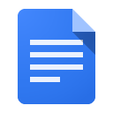
How to Write The Ultimate Guide

Infographics
Infographics | Woww guide included below
An infographic is a collection of imagery, charts, and minimal text that gives an easy-to-understand overview of a topic.
Using infographics strategically can be incredibly powerful to gain exposure and backlinks.

You can create Infographics with statistics related to your topic.

For example:
- Selling a House Fast in Pennsylvania: Timeline From First Call to Closing
- Cash Sale vs Traditional Sale: Key Differences for Homeowners
- What Happens When You Sell a House As Is?
- Common Costs When Selling a House
- What Closing Costs Do Sellers Usually Pay?
- How Cash Home Buyers Evaluate a Property
- Selling an Inherited House: Step-by-Step Process
- Selling a House With Tenants: Key Steps to Understand
- Selling a Fire-Damaged House: What Homeowners Need to Know
- Selling a House Before Foreclosure: Important Timeline Points
- Repairs vs Selling As Is: Which Route Makes More Sense?
You then share this with:
- Berks Weekly
https://berksweekly.com/
- Reading Eagle
https://www.readingeagle.com/
- LNP | LancasterOnline
https://lancasteronline.com/
- York Daily Record
https://www.ydr.com/
- The York Dispatch
https://www.yorkdispatch.com/
- The Pittsburgh Wire
https://www.thepittsburghwire.com/
- Real Estate Investors Association of Berks County
https://reiaberks.com/
- Philadelphia Real Estate Investors Association
https://www.meetup.com/philadelphia-real-estate-investors-association/
- Pennsylvania Apartment Association
https://www.paahq.com/
- Pennsylvania Association of Realtors - Local Associations
https://www.parealtors.org/local-associations/find-a-local-association/
- PHFA housing resources
https://www.phfa.org/
- PALawHELP housing resources
https://www.palawhelp.org/issues/housing-and-shelter/
Then keep/replace the paragraph below with:
This type of asset can be especially effective when tied to a useful homeowner or seller topic, such as selling a house fast, selling as is, understanding selling costs, inherited property, foreclosure timelines, or repair-heavy homes. The infographic gives local publications, real estate groups, homeowner resources, landlord/property management sites, and community organisations a simple visual resource that may be useful to their audiences.
The value exchange is straightforward: publishers receive a useful visual asset that helps explain a property-related issue, while Pikeland Property Group can build exposure, referral traffic, and relevant backlinks when credited as the original source.
Here’s a step by step guide for Creating An Infographic.

The Infographic - Step by Step Guide

Guest Articles
Guest Articles
Get industry experts to create awesome content for your website. Or, do the inverse and be the authority, and write guest articles for other sites and get them to provide you with a valuable backlink.

E.g: You could offer to write a guest article on:

- How Pennsylvania homeowners can sell an inherited house
- What sellers should know before accepting a cash offer
- Selling a house as is vs making repairs first
- How landlords can sell a rental property with tenants
- What to do if a home needs major repairs before sale
- Common fees homeowners forget when selling a house
- How to sell a vacant or distressed property
- How to prepare for a fast closing
- What homeowners should know about selling before foreclosure

You then share this with:
- Berks Weekly
https://berksweekly.com/
- Reading Eagle
https://www.readingeagle.com/
- LNP | LancasterOnline
https://lancasteronline.com/
- The York Dispatch
https://www.yorkdispatch.com/
- York Daily Record
https://www.ydr.com/
- The Pittsburgh Wire
https://www.thepittsburghwire.com/
- Real Estate Investors Association of Berks County
https://reiaberks.com/
- Philadelphia Real Estate Investors Association
https://www.meetup.com/philadelphia-real-estate-investors-association/
- Pittsburgh REIA
http://pittsburghreia.com/
- Pennsylvania Apartment Association
https://www.paahq.com/
- Pennsylvania Association of Realtors - Local Associations
https://www.parealtors.org/local-associations/find-a-local-association/
- City of Reading housing/development resources
https://www.readingpa.gov/
These are “outreach targets to qualify” rather than guaranteed placement opportunities. Some are better for contributor posts, some for PR, and some for relationship building or citation/link prospecting.

List Posts
List Posts | Woww guide included below
People love lists. Just be careful not to make content completely unrelated to your business (e.g. you have a popular list “10 easy tips to save water” which is a great article which drives traffic, but that traffic isn’t going to convert, because it’s completely unrelated).

These types of content are highly digestible due to their format, allow for easy population of relevant keywords when discussing the list items, and are easy to share.

They are also prime candidates for vanity sharing (easy backlinks).
Here are some ideas for list posts that you could write:

- 10 Things to Know Before Selling Your House Fast
- 10 Questions to Ask a Cash Home Buyer
- 10 Signs a Cash Offer May Be the Right Option
- 10 Things to Know Before Selling a House As Is
- 10 Repairs You May Not Need to Make Before Selling
- 10 Costs to Consider When Selling a House
- 10 Ways Selling to a Cash Buyer Is Different From Listing With an Agent
- 10 Things to Know Before Selling an Inherited House
- 10 Things to Know Before Selling a House With Tenants
- 10 Things to Know Before Selling a Fire-Damaged House
- 10 Things to Know Before Selling a House With Code Violations
- 10 Ways to Sell a House Faster in Pennsylvania

List posts can be written differently, short or incredibly long, and with more or less meat per list item. Here are step by step guides on how to write three types of List Posts:

How to Write The Assembled List Post

How to Write The Padded List Post

How to Write The Ultimate List

How to Guides
How to Guides | Woww guide included below
How to Guides offer incredibly actionable tips and advice for your audience.
Here are some great examples you could write about:

- How to Sell Your House Fast
- How to Sell Your House Fast for Cash
- How to Sell a House As Is
- How to Sell a House As Is Without Inspection
- How to Sell a House As Is by Owner
- How to Sell a Fire-Damaged House
- How to Sell a House With Code Violations
- How to Sell a Hoarder House
- How to Sell an Inherited House
- How to Sell an Inherited House With Multiple Heirs
- How to Sell a Rental Property
- How to Sell a House With Tenants
- How to Sell a Vacant House
- How to Sell a Distressed Property
- How to Sell a Fixer-Upper for Cash
- How to Get a Cash Offer for Your House
- How to Get a Fair Cash Offer for Your House
- How to Sell a House Before Foreclosure
- How to Sell a House Without a Realtor
- How to Work Out the Cost of Selling a House

These are two guides on how to write a highly actionable guide for your audience to follow.

These may not be entirely relevant to every topic you come up with but these guides still provide a good approach to putting together a How To Guide post.

How to Write The Step by Step Guide

How to Write The Yearly Manual

Roundups
Roundups | Woww guide included
Are a great tool to generate content. You can create a roundup list of relevant people or organizations, these are basically lists on steroids.
For example:
- 10 Resources for Homeowners Selling a House in Pennsylvania
- 10 Things Pennsylvania Homeowners Should Know Before Selling As Is
- 10 Useful Resources for Selling an Inherited House
- 10 Common Home Sale Costs Sellers Should Understand
- 10 Options for Selling a House That Needs Repairs
- 10 Ways to Sell a House Fast in Pennsylvania
- 10 Resources for Landlords Selling a Rental Property
- 10 Resources for Homeowners Facing Foreclosure
- 10 Things to Compare Before Choosing a Cash Home Buyer
- 10 Local Resources for Homeowners in Reading, PA
- 10 Local Resources for Homeowners in Lancaster, PA
- 10 Local Resources for Homeowners in York, PA

Here are guides for creating two types of roundup posts. These are especially helpful Content Frameworks to use when you’re just getting started or when you’re trying to expand your network and build relationships.

How to Write The Gathered Experts Guide

How to Write The Recognition Lure

Experts that contribute will be happy to share your page with their audience. Which means you can get A LOT of traffic very quickly, even if your site is brand new.

Versus Posts
Versus posts are excellent for comparison-based content that helps readers make informed decisions. These posts directly compare two products, tools, ingredients, or concepts — showing their similarities, differences, and which one is better suited for specific needs.

They’re especially effective for driving decision-stage traffic, building topical authority, and improving LLMO performance, as comparison content aligns naturally with the way large language models interpret and summarise nuanced trade-offs between options.

They are especially useful for decision-stage traffic because users are often comparing a cash sale, traditional sale, agent-led sale, or as-is sale before taking action.
- Sale method comparisons
  - Cash Home Buyer vs Real Estate Agent: What Is the Difference?
  - Selling to an Investor vs Listing on the Market
  - Selling Without a Realtor vs Selling to a Cash Buyer
  - Cash Offer vs Traditional Sale: Which Is Faster?
  - Direct Home Buyer vs Traditional Buyer: What Sellers Should Know
- As-is and repair comparisons
  - Selling As Is vs Making Repairs: Which Option Makes More Sense?
  - Selling a Fixer-Upper vs Renovating Before Sale
  - Selling a Fire-Damaged House As Is vs Repairing It First
  - Selling a House With Code Violations vs Fixing Violations First
  - No Inspection Sale vs Traditional Inspection: What Changes?
- Seller situation comparisons
  - Selling an Inherited House vs Keeping It as a Rental
  - Selling a Rental Property vs Keeping Tenants
  - Selling a House With Tenants vs Waiting Until It Is Vacant
  - Selling Before Foreclosure vs Waiting: What Homeowners Should Know
  - Selling a Vacant House vs Renting It Out
- Cost and timeline comparisons
  - Closing Costs vs Realtor Fees: What Sellers Should Understand
  - Cash Offer Timeline vs Traditional Closing Timeline
  - Fast Closing vs Flexible Closing: Which Is Better for Sellers?
  - Selling for Cash vs Paying for Repairs First
  - Traditional Sale Costs vs Cash Sale Costs
- Location and buyer comparisons
  - Cash Home Buyers in Pennsylvania vs National Home Buying Companies
  - Local Cash Home Buyers vs National Home Buyers
  - Selling a House Fast in Reading vs Lancaster: What Sellers Should Know
  - Selling a House Fast in York vs Pittsburgh: What Sellers Should Know
Legal review is recommended for any versus post that compares competitors, discusses foreclosure, or makes claims about cost savings, timelines, fees, taxes, or legal outcomes.

Landing Page Ideas & Optimisations
Landing Page Ideas
You may consider creating landing pages that target highly relevant long-tail searches around cash home buyers, fast home sales, as-is property sales, inherited houses, distressed properties, repair issues, costs, and Pennsylvania service areas.
These pages should not just swap out the location or situation name. Each one should include useful, specific information, clear next steps, trust signals, FAQs, internal links, and a direct offer CTA.
*Some of these page suggestions below, such as location pages, exist already but are not ranking for their target keywords at present, and required further on-page content optimisation and better internal linking. There is room to create additional landing pages based on themes such as situation/circumstances, as-is and repair issues, property type, and more.
- Location pages
  - Sell My House Fast in Reading, PA
  - We Buy Houses in Reading, PA
  - Sell My House Fast in Lancaster, PA
  - Cash Home Buyers in Lancaster, PA
  - Sell My House Fast in York, PA
  - Cash Home Buyers in York, PA
  - Sell My House Fast in Pittsburgh, PA
  - We Buy Houses in Pittsburgh, PA
  - Sell My House Fast in Philadelphia, PA
  - Sell My House Fast in Wilmington, DE
  - Sell My House Fast in West Chester, PA
  - Sell My House Fast in Chester County, PA
  - Sell My House Fast in Bucks County, PA
- Cash home buyer pages
  - Cash Home Buyers in Pennsylvania
  - Local Cash Home Buyers
  - Direct Home Buyers
  - Reputable Cash Home Buyers
  - Sell My House for Cash
  - Cash for Houses in Pennsylvania
  - How Our Cash Offer Process Works
- As-is and repair issue pages
  - Sell Your House As Is
  - Sell Your House As Is for Cash
  - Sell a House With No Inspection
  - Sell a Fire-Damaged House
  - Sell a House With Code Violations
  - Sell a Damaged House
  - Sell a Fixer-Upper for Cash
  - Sell a House in Any Condition
- Property type and seller situation pages
  - Sell an Inherited House
  - Sell a Rental Property
  - Sell a House With Tenants
  - Sell a Vacant House
  - Sell a Probate Property
  - Sell a Hoarder House
  - Sell a Distressed Property
  - Sell a Manufactured Home
  - Sell an Unwanted Property
- Fast offer and process pages
  - Get a Cash Offer for Your House
  - Request a No-Obligation Cash Offer
  - Sell Your House in 7 Days
  - Sell Your House Without Showings
  - Choose Your Closing Date
  - How Pikeland Property Group Buys Houses
  - What Happens After You Request a Cash Offer?
- Cost, fee, and net proceeds pages
  - Cost of Selling a House
  - Fees for Selling a House
  - Realtor Fees for Selling a House
  - Closing Costs When Selling a House
  - Who Pays Closing Costs When Selling a House?
  - Net Proceeds From Selling a Home
  - Cash Sale vs Traditional Sale Costs
These pages should be prioritised based on commercial intent, relevance to Pikeland’s actual service areas, and whether the page can provide useful content beyond a thin keyword-targeted landing page.

Final thoughts on content creation

Final thoughts on content creation
Pages must have purpose: Pikeland Property Group has clear SEO opportunities across cash home buyer, sell my house fast, as-is sale, inherited property, distressed property, repair issue, process, and cost-related searches, but these should not all be forced onto the homepage or a small group of broad service pages. Improving the quality, usefulness, SEO value, and conversion potential of the pages that matter most should be the priority.
In particular, the homepage, core location pages, and any dedicated cash offer, as-is, fast sale, inherited property, foreclosure, and cost/fees pages should be treated as priority pages. The homepage should act as a clear gateway into the main offering, while dedicated subpages should target more specific search intent such as sell my house fast Reading PA, we buy houses Lancaster PA, cash home buyers York PA, sell house as is, cash offer for my house, sell inherited house, and cost of selling a house.
For a real estate investment / home buying website, content should also be reviewed through a trust and compliance lens. Pages should include clear service information, honest expectations, location relevance where applicable, accurate process details, proof points where available, and links to relevant support or professional resources. Avoid creating content that implies guaranteed outcomes, fixed sale prices, legal certainty, tax advice, or unrealistic closing timelines.
Be thoughtful about linking: Internal linking should be used much more deliberately to strengthen the most important landing pages and topic clusters. One of the clearest opportunities is to use short descriptions, FAQs, and contextual links on the homepage and supporting pages to connect users to the most relevant sections of the site. For example, the homepage should link clearly to Sell My House Fast, Cash Home Buyers, Sell As Is, Locations, Inherited Property, Foreclosure, Cost/Fees, and Contact / Get Offer pages.
Blog and educational content should also be organised into clearer topic clusters around fast home sales, cash buyers, as-is sales, inherited property, distressed properties, repair issues, selling costs, and Pennsylvania service areas. These articles should link back into the relevant commercial or functional pages using descriptive, keyword-relevant anchor text. This is particularly important for helping deeper pages build more topical authority and for guiding users from informational content into offer-focused pages.
Carefully consider keywords: Continue to prioritise keywords that reflect clear search intent and the ways homeowners actually search for help selling a property. For Pikeland, this includes terms such as sell my house fast, we buy houses, cash home buyers, sell my house for cash, sell house as is, sell inherited house, sell rental property, sell fire damaged house, sell house with code violations, cash offer for my house, cost of selling a house, closing costs when selling a house, and city-led searches across Reading, Lancaster, York, Pittsburgh, Philadelphia, Wilmington, West Chester, Chester County, Bucks County, and wider Pennsylvania.
Location-led terms such as sell my house fast Reading PA, we buy houses Reading PA, sell my house fast Lancaster PA, cash home buyers Lancaster PA, sell house fast York PA, sell my house fast Pittsburgh PA, and sell my house fast Philadelphia PA represent strong commercial intent and should be handled carefully with dedicated, useful location pages rather than thin duplicate templates.
Create landing pages and supporting content where there is a genuine page purpose. The clearest landing page opportunities are around location pages, cash home buyer pages, as-is and repair issue pages, property type / seller situation pages, fast offer and process pages, and cost / fee / net proceeds pages.
Publish Roundup posts, Versus posts, Ultimate Guides, How-to Guides, List Posts, and short evergreen articles only where they support a clear content strategy. These should help build topical authority, answer real user questions, and internally link back to the most relevant commercial pages.
Remember to use supporting keywords more often in supporting headings, FAQs, internal links, image filenames, alt text, meta titles, and meta descriptions.
Include a Call to Action: Every page should give users a clear next step. For Pikeland Property Group, this may include requesting a cash offer, calling the team, submitting property details, learning how the process works, viewing relevant service area pages, comparing sale options, or reading related guidance.
Calls to action should be tied closely to the purpose of the page. Informational content should guide users toward the relevant landing page or support resource, while commercial pages should support stronger actions such as requesting an offer, calling Pikeland, or starting the sale process.
Prioritise expanding and refining existing high-value pages first, especially the homepage and location pages, with stronger keyword targeting, more useful supporting content, clearer headings, and better internal linking.
Then develop targeted landing pages for cash buyers, fast sales, as-is property sales, inherited houses, distressed properties, repair-heavy houses, foreclosure-related situations, process questions, costs/fees, and important service areas. Each page should be supported with useful content, local relevance where applicable, and internal links from related guides and blog posts.

Content Promotion and Outreach Strategy
It's no good creating all this amazing content if no one is going to read about it. No longer does the rule “build it and they will come” apply, you cannot “publish and pray”, you need to “publish and promote”. Below, we propose the best ways to get your content noticed.

lCONTENT PROMOTIONl l& OUTREACHl

Link Creator Database creation
Link Creator Database creation
A link creator is a person, company, publisher, or platform that has the ability to link to your website.
The goal is to identify websites and contacts that are relevant to Pikeland Property Group, then create content that is useful not only to potential property sellers, but also to the types of publishers, blogs, directories, local organisations, and industry websites that can share and link to it.
For Pikeland Property Group, this could include Pennsylvania real estate publications, local news websites, homeowner resources, landlord and property management websites, real estate investor groups, estate planning resources, moving and relocation websites, legal/housing resources, local business directories, and community organisations.
Once this database is built, it can be used whenever new content is published. This makes it easier to do targeted outreach by email or social media and increase the chances of earning relevant backlinks.
Outreach in this niche should be handled carefully. Any content involving probate, foreclosure, tax, legal, tenant, lien, or financial topics should be accurate, clearly explained, and reviewed where needed before being promoted.
Useful guides:

Renovating Broken Links

Renovating Outdated Links

Social Media Promotion
Social Media Promotion
Social media is a potential marketing avenue. The type of content you create can appeal to different groups of people. Keeping an engaged audience will result in brand awareness and building up a reputation.
For Pikeland Property Group, this means sharing useful content across platforms where homeowners, landlords, property investors, and local communities are active. This could include short educational posts, seller tips, property situation explainers, before-and-after case studies where appropriate, FAQs, and location-specific content.
Every time a relevant piece of content is created on the website, share it on each active platform, especially Facebook, LinkedIn, Google Business Profile, and relevant local community groups where appropriate.
Social promotion should also support seasonal or situation-led opportunities, such as tax season, inheritance/probate questions, foreclosure timelines, storm or fire damage, tenant issues, and moving deadlines.
Suggested social post themes:
- How cash home buyers work
- What it means to sell a house as is
- Selling an inherited house
- Selling a house with tenants
- Selling a fire-damaged or damaged house
- Selling before foreclosure
- Understanding closing costs
- How fast a cash sale can close
- Local seller tips for Reading, Lancaster, York, Pittsburgh, and Philadelphia
All social content should avoid legal, tax, or financial advice unless reviewed by a qualified professional.
Here are some resources for content marketing and social media:

The Feedback to Share Approach

The Targeted Sharers Technique

Forum Marketing

The Content Roadshow

PPC
PPC
PPC can be used strategically to amplify high-value content and drive targeted traffic from users who are actively searching for relevant solutions.
For Pikeland Property Group, this could include promoting key landing pages such as Sell My House Fast in Reading PA, Cash Home Buyers in Lancaster PA, Sell My House Fast York PA, Sell Your House As Is, Get a Cash Offer for Your House, Sell an Inherited House, and Sell a House Before Foreclosure.
This may be especially useful for high-intent keywords where organic rankings will take time to build, such as:
- sell my house fast reading pa
- we buy houses lancaster pa
- cash home buyers york pa
- sell my house fast pittsburgh pa
- sell my house fast philadelphia pa
- sell house as is for cash
- get cash offer for house
- sell inherited house
- sell house before foreclosure
Rather than using PPC only for direct lead generation, it can also support broader marketing goals by increasing exposure for useful content, strengthening brand visibility, and driving more qualified users to the website.
PPC activity should be reviewed carefully to ensure landing pages are accurate, compliant, and do not make unsupported claims about guaranteed offers, sale timelines, fees, foreclosure outcomes, or legal/tax matters.

Strategic Partnerships and existing authority sites
Strategic Partnerships and existing authority sites
Pikeland Property Group can strengthen its backlink profile by building relationships with relevant authority sites and industry partners. This could include Pennsylvania publishers, real estate investment groups, landlord associations, property management websites, estate planning resources, relocation companies, local business organizations, and community websites.
These partnerships could support content around selling houses fast, selling as is, cash offers, inherited property, probate situations, rental properties, tenants, foreclosure, repair-heavy homes, and local Pennsylvania homeowner resources.
Potential partnership targets to qualify:
- Real Estate Investors Association of Berks County
https://reiaberks.com/
- Philadelphia Real Estate Investors Association
https://www.meetup.com/philadelphia-real-estate-investors-association/
- Pittsburgh REIA
http://pittsburghreia.com/
- Pennsylvania Apartment Association
https://www.paahq.com/
- Pennsylvania Association of Realtors - Local Associations
https://www.parealtors.org/local-associations/find-a-local-association/
- Berks Weekly
https://berksweekly.com/
- The Pittsburgh Wire
https://www.thepittsburghwire.com/
Partnership and outreach opportunities should be reviewed carefully so that links come from reputable, relevant websites and do not create trust issues.
Useful promotional/link building angles could include:
- Local homeowner resources
- Selling inherited property guides
- Selling as-is property guides
- Landlord and rental property content
- Fire-damaged or repair-heavy property explainers
- Pennsylvania selling cost guides
- Local market or homeowner checklists
Here are some useful promotion and link building strategies for Infographics:

The Infographic Sources Bait

The Infographic Reverse Search Approach

The Infographic Exclusive

Manual & automated outreach
Manual & automated outreach
Outreach can help Pikeland Property Group promote content, build relationships, and earn relevant backlinks. A mix of manual and automated outreach can be used to contact relevant publishers, partners, and websites at scale while still keeping messaging targeted and personalised.
Manual outreach should be prioritised for high-value contacts, such as local publishers, real estate investor associations, landlord/property management groups, estate planning websites, and community organizations.
Automated outreach can be useful for larger prospect lists, but messaging should still be carefully segmented by topic. For example, inherited property content should be pitched to estate planning and probate resources, rental property content should be pitched to landlord/property management sites, and local guides should be pitched to community publications.
The best outreach targets are likely to be:
- Resource pages
- Relevant roundup posts
- Local directories
- Community news sites
- Real estate investing resources
- Property management blogs
- Estate planning resources
- Local business association pages
- Pages already covering selling houses, cash buyers, landlord issues, probate, foreclosure, or homeowner support
You can also find authority blogs or sites with pages that could link well to the content you produce using guides such as:
- Targeting Resource Pages
- Targeting “Best of” Posts
- Targeting Roundup Posts
- Renovating Broken Links
- Renovating Outdated Links
You can also find authority blogs or sites with pages that could link quite well to content you produce using these useful guides:

Targeting Resources Pages

Targeting 'Best of' Post

Targeting Roundup Posts


Summary and Conclusion
lSUMMARY &l lCONCLUSIONl

Summary and Conclusion
Pikeland Property Group has clear opportunities to improve organic visibility across high-intent property seller searches, especially around cash home buyers, sell my house fast, we buy houses, as-is property sales, inherited houses, distressed properties, repair-heavy homes, foreclosure-related situations, selling costs, and local Pennsylvania service-area searches.
The current state is that Pikeland has no keyword rankings at the time of the audit, either globally or in the United States.
The 12-month comparison also shows 115 lost rankings, including commercially relevant terms such as sell my house fast reading pa, we buy houses reading pa, sell my house fast lancaster pa, cash home buyers lancaster pa, sell my house fast york pa, and sell my house fast pittsburgh pa. This suggests that the site is not currently capturing the level of organic demand available in its market, and that previous visibility has either been lost or is not being supported clearly enough by the current page structure and content.
Pikeland Property Group already has the foundations of a stronger organic search strategy, with a relevant commercial offer, location pages, a cash offer page, process content, repair-related articles, cost content, FAQ content, and direct buyer articles already in place.
However, the current SEO structure is not yet doing enough work. Several high-value keyword themes do not have a clear, purpose-built page, while others appear to be supported by content that is too broad, too overlapping, or not closely enough aligned with the specific search intent.
The first priority should be improving the pages that matter most. This includes the homepage, Get Your Offer page, How We Buy Houses page, core location pages, existing direct buyer articles, existing repairs/as-is content, existing cost articles, FAQ pages, and reviews/trust pages.
These should be strengthened with clearer keyword targeting, better metadata, stronger headings, more useful copy, FAQs, trust signals, and stronger calls to action.
The site would also benefit from creating dedicated landing pages where no clear indexable match exists. This includes topics such as inherited houses, hoarder houses, fire-damaged houses, houses with code violations, distressed properties, and more specific cash buyer / as-is sale pages.
These should not be thin keyword pages; each page should provide useful information, explain the seller situation clearly, and guide users toward requesting an offer.
Blog content also needs to play a clearer strategic role. Pikeland should not create blogs simply to increase publishing volume; blogs should be used to capture informational and comparison-led searches that support the main commercial pages.
Topics such as selling a house as is, selling an inherited house, selling a house with tenants, selling a fire-damaged property, avoiding repair costs, understanding closing costs, and comparing cash buyers with estate agents can help bring in earlier-stage sellers while internally linking users toward the Get Your Offer page, location pages, and relevant cash buyer/service pages.
Existing blog content should also be reviewed and improved before too much new content is created. Pikeland already has useful articles around selling to a direct buyer, selling a property that needs repairs, selling vacant or abandoned homes, and the costs of selling a house in Pennsylvania, but some of these pages appear too broad, overlapping, or under-optimised to carry their full SEO value.
Updating these blogs with stronger keyword targeting, clearer headings, better FAQs, more specific seller scenarios, improved metadata, and more deliberate internal links would help the site build topical authority while supporting the commercial pages most likely to generate leads.
There are also several on-page SEO and content issues that should be addressed. These include weak or template-style metadata, missing or underdeveloped meta descriptions, heading improvements, image alt text opportunities, shallow internal linking, possible overlap across similar direct buyer posts, and existing blog/FAQ content that could be consolidated or improved.
Fixing these issues will improve crawl clarity, search intent alignment, user experience, and the commercial value of the site.
Because Pikeland’s content often touches legal, financial, tax, foreclosure, probate, tenant, lien, and cost-related topics, these pages should be written carefully and reviewed where needed before publication.
Finally, content creation should be supported by promotion and outreach. Pikeland should build relationships with relevant Pennsylvania publications, real estate investor groups, landlord/property management resources, estate planning websites, relocation resources, and local community sites.
Fewer, stronger content assets promoted deliberately will be more valuable than publishing large volumes of unsupported blog content.

Areas for Improvement
Here we will discuss the sections of this audit and what actions we suggest you take to address the problems.

Keywords
KEYWORDS | 7+ suggested actions
Pikeland Property Group has clear keyword opportunities across cash home buyer, sell my house fast, we buy houses, as-is sale, inherited property, distressed property, repair issue, cost, and local Pennsylvania service-area searches.
The main opportunity is to give each important keyword theme a clearer destination page, rather than relying too heavily on the homepage, location pages, or broad blog content to cover multiple different seller intents.

Actions suggested:

- Rebuild visibility around commercially valuable terms such as sell my house fast, we buy houses, cash home buyers, sell house as is, and sell my house for cash.
- Prioritise local service-area keywords such as sell my house fast Reading PA, sell my house fast Lancaster PA, sell my house fast York PA, sell my house fast Pittsburgh PA, sell my house fast Philadelphia PA, and sell my house fast Wilmington DE.
- Review the previous lost rankings and ensure each keyword is mapped to the most relevant page, especially where location terms were previously associated with the wrong location URL.
- Strengthen existing location pages so each page clearly targets its own city or service area, with unique copy, local relevance, FAQs, trust signals, and stronger calls to action.
- Create or improve dedicated pages for important seller situations such as selling an inherited house, selling a hoarder house, selling a fire-damaged house, selling a house with code violations, selling a house with tenants, and selling a distressed property.
- Use keyword variations more deliberately across H1s, meta titles, supporting headings, FAQs, internal links, image filenames, and alt text.
- Use question-led keyword research to support helpful blogs and FAQs around as-is sales, cash offers, inherited houses, closing costs, repairs, foreclosure-related situations, and selling without an estate agent.
- Avoid creating thin keyword pages. Each landing page or blog should have a clear purpose, answer a real seller's need, and guide users toward requesting an offer where relevant.

On Page SEO
ON PAGE SEO | 15+ suggested actions
The main on-page issues relate to weak or generic metadata, missing or underdeveloped meta descriptions, heading structure improvements, image optimisation gaps, shallow internal linking, and content that does not always fully match the search intent.

At present, several important keyword themes either have no clear page, or are supported by pages that need stronger targeting, clearer structure, and more useful copy before they can compete properly.

Actions suggested:

Page titles:

- Rewrite short, generic, or template-style page titles on important pages.
- Ensure each indexable page has a unique title aligned with its target keyword and search intent.
- Update the homepage title so it better reflects Pikeland’s broader commercial offer, including cash home buying, fast house sales, and Pennsylvania relevance.
- Update location page titles so each one clearly reflects the target city and primary seller intent.
- Improve blog titles where the current title does not clearly reflect the keyword opportunity or the searcher’s question.

Meta descriptions:

- Write unique meta descriptions for important indexable pages currently missing them or using weak descriptions.
- Prioritise the homepage, Get Your Offer page, How We Buy Houses page, core location pages, key blog posts, and important FAQ pages.
- Include clearer calls to action in metadata, such as requesting a cash offer, selling a house as is, avoiding repairs, or getting help with a difficult property situation.
- Make meta descriptions more specific to the page topic, rather than using broad or repeated wording across similar pages.

OG Tags & Twitter Cards:

- Add or improve Open Graph tags on important canonical, indexable pages.
- Add or improve Twitter Card tags where they are missing or incomplete.
- Use accurate titles, descriptions, and branded social preview images for pages likely to be shared or promoted.

H-tag structure:

- Ensure each priority page has one clear H1.
- Update H1s so they reflect the specific page intent, such as selling a house fast in a specific location, getting a cash offer, or selling a house as is.
- Improve heading hierarchy across the homepage, location pages, Get Your Offer page, How We Buy Houses page, and priority blog posts.
- Add supporting H2s for common seller questions, process details, trust signals, timelines, fees, property condition, and next steps.

Alt text:

- Add missing alt text to important images.
- Rewrite generic alt text where more descriptive wording would help users and search engines understand the image.
- Use image filenames and alt text to support the page topic naturally, especially on location pages, cash offer pages, repair/as-is content, and trust pages.

Links
Links | 7+ suggested actions
The main link-related opportunity is to use internal linking more deliberately to strengthen priority pages. Pikeland already has useful pages and blog content, but the relationships between commercial pages, supporting articles, FAQs, and location pages need to be clearer.

Internal links should help Google understand which pages matter most, while also helping users move from educational content toward offer-request and service pages.

- Add more contextual internal links from the homepage to the Get Your Offer page, How We Buy Houses page, core location pages, and priority seller-situation pages.
- Use existing blogs and FAQs to link back into the most relevant commercial pages, especially where the blog explains a problem that Pikeland can help solve.
- Use descriptive internal anchors such as sell your house fast in Reading PA, cash home buyers in Pennsylvania, sell your house as is, get a cash offer, and how we buy houses.
- Replace generic anchor text such as click here, read more, learn more, or this page where a more descriptive anchor would improve context.
- Build clearer topic clusters around cash home buyers, as-is property sales, inherited houses, distressed properties, repairs, costs, and local Pennsylvania locations.
- Update redirecting internal links so they point directly to final 200-status URLs where possible.
- Link from location pages to relevant supporting articles, such as cost guides, repair/as-is content, direct buyer articles, and FAQs.
- Link from new and optimised blog posts back to the most relevant location or offer page, rather than only linking to the homepage.
- Review outbound links in legal, financial, tax, foreclosure, probate, tenant, and cost-related content to ensure sources are live, accurate, and trustworthy.

Content
CONTENT | 7+ suggested actions
The strongest content opportunity is to improve existing high-value pages first, then expand into dedicated landing pages and supporting blog content. The homepage, Get Your Offer page, How We Buy Houses page, location pages, and existing high-intent blog posts should be prioritised before publishing large volumes of new content.
New content should only be created where there is a genuine page purpose, keyword opportunity, and clear relationship to Pikeland’s commercial pages.
Actions suggested:

- Improve the homepage so it acts as a clearer gateway into Pikeland’s main services, locations, process, trust signals, and offer-request journey.
- Strengthen the Get Your Offer page with clearer copy around how the cash offer process works, what sellers can expect, trust signals, FAQs, and stronger calls to action.
- Improve the How We Buy Houses page so it explains the process more clearly and links to relevant supporting pages, such as cash offers, as-is sales, location pages, and seller situation pages.
- Expand and improve core location pages with more unique local copy, stronger headings, FAQs, proof points, and links to related supporting content.
- Create dedicated landing pages for missing high-value topics such as inherited houses, hoarder houses, fire-damaged houses, houses with code violations, distressed properties, rental properties, tenant-occupied houses, and as-is cash sales.
- Optimise existing blog content around selling to a direct buyer, selling a property that needs repairs, selling vacant or abandoned homes, and the costs of selling a house in Pennsylvania.
- Consolidate or differentiate overlapping direct buyer articles where multiple posts are covering similar intent without a clear strategic purpose.
- Create supporting blogs where they help capture informational or comparison-led searches, such as how to sell a house as is, how to sell an inherited house, cash buyer vs estate agent, how much does it cost to sell a house, and can you sell a house with tenants.
- Add FAQs to priority pages and blog posts where they support search intent, answer seller objections, and create opportunities for internal links.
- Improve content quality with clearer seller scenarios, process detail, trust signals, proof points, location relevance, and careful handling of legal, financial, tax, foreclosure, probate, tenant, lien, and cost-related topics.
- Review thin or low-purpose pages and decide whether they should be improved, consolidated, redirected, noindexed, or removed.
- Prioritise short-form evergreen content, long-form guides, how-to guides, roundups, versus posts, and landing pages only where they support clear keyword intent and can be promoted effectively.

Appendices
This audit is made possible due to the research and efforts of Google and the SEO community.

Here are a number of incredible tools, articles and resources that we used to develop and perform this audit.
https://www.digicert.com/ssl/
lAPPENDICESl
https://analytics.google.com
https://search.google.com
https://tools.pingdom.com/
https://gtmetrix.com/
https://www.webpagetest.org/
https://transparencyreport.google.com
https://yoast.com/
https://yoast.com/meta-descriptions/
https://sitecheck.sucuri.net
https://ahrefs.com/
http://www.copyscape.com/
https://www.gotchseo.com/seo-audit/
https://neilpatel.com/blog/seo-website-audit/
https://backlinko.com/google-ranking-factors
https://backlinko.com/seo-site-audit
https://backlinko.com/on-page-seo
https://backlinko.com/link-building-strategies
https://www.searchenginejournal.com/the-ultimate-seo-audit-checklist/
https://www.thehoth.com/blog/google-medic-update/
https://barracuda.digital/panguin-seo-tool/
https://www.reliablesoft.net/seo-checklist/
https://www.google.com/business

